Outdoor Dance
Commissions Brief
Dance City and Festival of Thrift
Introduction
Dance City and Festival of Thrift are inviting dance and physical performance artists/companies to create a new outdoor work to be commissioned for Festival of Thrift 2021.
Background
Dance City
Established for over 30 years Dance City is the North East’s leading development organisation for dance, which exists to lead and support a thriving dance ecology in the region.
Dance City presents a regular programme of dance performances from contemporary to ballet, world to breakdance bringing leading North East, British and international dance to Newcastle upon Tyne.
It also commissions original new works, which premiere in its theatre and beyond. Dance City’s vision is to ensure that the North East is the best place to be a professional dance artist. Its mission is to provide excellent training, support, networking and funding opportunities for North East professional dance/movement artists.
As the only regional commissioning body for dance, Dance City has been reviewing its commissioning processes making them more inclusive and accessible to all forms of dance work, such as live stage performances, outdoor work, and dance film, striving to find new ways to support exciting new choreography.
Festival of Thrift
Festival of Thrift positions artists as inspirers to action and encouraging change through a free programme of workshops, exhibitions and performances giving families the confidence to create while having fun on a budget. We established Festival of Thrift CIC in 2015 with a mission to benefit the community and advance public awareness of sustainable living.
Now based in Redcar, Festival of Thrift reaches new audiences from all over the UK year on year, building new partnerships with organisations who share its ethos.
Festival of Thrift’s focus has always been on how individuals can make those small changes – the shift to thrift – that will add up to a big difference for the future of our planet, and encouraging others to join in.

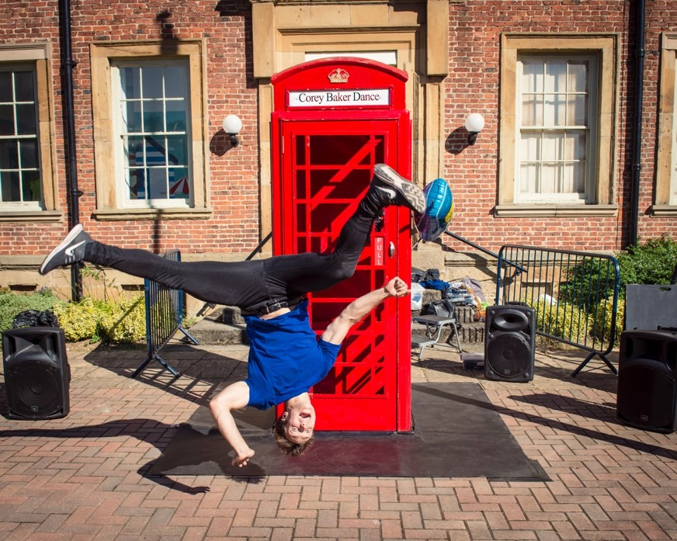

Phone Box by Corey Baker Dance at Festival of Thrift 2016
The Event
Festival of Thrift is the UK’s national Festival of sustainability.
Usually taking place over two days in Kirkleatham near Redcar on the North East coast, this hugely popular festival celebrates the joys of a climate-friendly way of life. Families, fashionistas, foodies, upcyclers, recyclers and eco-warriors are amongst the thousands who flock to the festival each year to make, eat, play, share and learn through a host of activities and entertainment.
The Festival takes place over a large greenfield site across the village of Kirkleatham, near Redcar on the North East Coast. The site is spread over a variety of settings including hardstanding, grassed, woodland, tented, outdoor & indoor with activity also taking place in the Museum, Walled Garden, church & school.
Festival of Thrift is set to return to Kirkleatham on Saturday 25 and Sunday 26 September 2021.
Please note that the delivery of Festival of Thrift 2021, and therefore this commission is dependent on the successful outcome of an Arts Council England Project Grant, which is currently being assessed. The outcome is likely to be received at the end of June.

Brief
Dance City and Festival of Thrift are inviting one dance artist or company to propose a new outdoor work to be commissioned to the value of £8,000 for Festival of Thrift 2021.
Dance City has an exemplary track record in commissioning and programming indoor dance works, and through commissioning activity in 2021 is looking to broaden its reach to connect with more artists, audiences and places across the region, by taking dance outside of its purpose-built facilities to spaces where communities meet.
Festival of Thrift regularly programmes and commissions new outdoor works including temporary public artworks and performance.
Artists are asked to respond to the broad theme of future sustainability, to
be interpreted in whichever way they see fit. We are particularly keen to see proposals that respond to this year’s Festival theme of Water. The theme coincides with the first Year of the English Coast where we will explore a range of issues including rising sea levels due to climate change, water pollution, water safety and reducing water use, as well as inviting artists to explore the theme creatively.
We are seeking creative ideas that are high quality, engaging and accessible, but also challenging and thought provoking. We are particularly interested in those which are site specific/sympathetic and forward looking. Artists must demonstrate that the work is relevant to its context and that it properly responds to the theme.
We welcome proposals which include an element of community engagement or participation either online, remotely, or in a way which follows social distancing measures if required and that could allow for participation of those that may not have access to the internet. Please ensure this is detailed in your proposal, if applicable.
We are committed to reducing our carbon footprint and we expect to see proposals that do not need to be powered in any way or which utilise low energy formats and consider transport distances. We also expect proposals which take into consideration sustainable options for production of set, props and costumes.

Eligibility
Proposals should be for new commissions or work currently at an early stage of research and development. Proposals for the presentation or adaptation of existing works will not be accepted.
This opportunity is open to individual dance artists or companies or collaborations between a dance company and artist(s) from another discipline.
The artist/company can be makers of dance or physical theatre work of any genre. Artists are welcome to work with collaborators from other mediums in the development of the work.
The work can be any style of dance or movement. It can be a solo, duet or group work.
The work must be of a professional standard and feature professional artists. Non-professional performers are welcomed in addition to the professional cast.
Applications are welcome from across the UK.
We actively encourage applications from artists who self-identify as Black, Asian, ethnically diverse, Lesbian, Gay, Bisexual, Transgender, Queer, Intersex, Asexual, d/Deaf, neurodiverse, and disabled.
Location
The work will be presented on the Festival of Thrift site, which is in the village of Kirkleatham near Redcar on the North East coast.
We are particularly interested in proposals which are site specific/sympathetic and have therefore not specified locations for the work and encourage artists to consider where they would like the work to be sited.
The sites across Kirkleatham are very varied and include grassed areas (fields and lawns), hardstanding (roads, paving and car parks), an enclosed stable block, woodlands and church yard.
Works can be proposed for specific sites within the village, or for more generic siting, for example on level hard standing. Please detail this in your proposal.
An illustrated plan of the Festival site can be found here: https://brainboxstudios.sharepoint.com/:b:/g/EZOtCLbooOpDoA8nkDp-l8sBB7SueGgEXbswj5-nJ2HpXg?e=98tBbX
You may wish to undertake your own site visit in advance of submitting a proposal, but this will be at your own expense.

Key Considerations
The most important consideration is how the piece will work within the context of an outdoor festival for a large and transient audience, but here are some specifics you should bear in mind whilst coming up with your idea:
- In a normal year, Festival of Thrift attracts a very large audience of between 35,000 and 40,000 people over the two-day event. Proposals should consider how a large, standing audience will have the best experience of the work.
- The event will go ahead in all but the most inclement of weathers. Performances must be designed to reliably withstand all weathers for the duration of the event.
- Performances should be no longer than 30 minutes in length.
- The Festival attracts a very broad audience across all age ranges and is particularly popular with family groups including young children.
- Two weeks of studio space, and one day of technical support for the development/rehearsal process of the work will be provided by Dance City. If the work requires more than this it should be factored into the budget.
- Transport of performers, set/props and costume to the site should be factored into the budget for the work.
- A technical rehearsal onsite can take place on Friday 24 September.
- The Festival is open to the public from 10am until 5pm each day. Please consider the number of performances that will be possible per day.
- You will be required to provide a risk assessment for approval by Dance City and Festival of Thrift, including how the performance will adhere to COVID-19 restrictions for performers and audiences.
- Artists and performers must have Public Liability Insurance.
- The artist/company is responsible for seeking all permissions and licenses for music used, and gaining correct approval from PRS, including paying any royalties due.
- Artists may also wish to consider how they might create the work to be toured and promoted beyond its presentation at Festival of Thrift.
- We would welcome creative approaches to documenting the making process of the work to be shared with both commissioners and through marketing activity if appropriate.
Support to the artist/company includes:
- Producer support and advice throughout the development and making process from Dance City and Festival of Thrift.
- One day of technical support from Dance City for the development and making process.
- Technical support from Festival of Thrift for the install, tech rehearsal onsite, duration and de install at Festival of Thrift.
- Local advice on community engagement from Festival of Thrift.
- Two weeks of studio space at Dance City Sunderland on 6-10 September and 13-17 September 2021.
- Marketing support via Dance City and Festival of Thrift.
Budget
The inclusive budget available for this commission and performances is £8,000 (inclusive of VAT).
The commission total is inclusive of all artists fees, collaborator fees, materials, costume, set, props, technical equipment hires, transport, travel, accommodation, and subsistence costs associated with the work, so your initial indicative budget will need to demonstrate this.
Timeline
Proposal Deadline | 12noon, Friday 2 July
Shortlisting Stage One applications | Monday 5 June – Friday 9 July
Artists notified of outcome | Monday 12 July
Stage Two – Interviews (via Zoom) | Wednesday 14 July (a £30 stipend (inc VAT) is paid to artists unsuccessful at interview, paid by BACS upon receipt of an invoice)
Artists notified of outcome | Thursday 15 July

Stipends:
The following stipends will be available to proposing artists/companies:
Stage One: No stipend
Stage Two: £30 stipend to artists unsuccessful at interview
(The above amounts are inclusive of VAT and will be paid by BACs upon receipt of an invoice.)
Application Process
Written Applications
Written proposals must be submitted via our online portal using the link below:
https://docs.google.com/forms/d/e/1FAIpQLSdv5_38QLhmXSaWdrSaHpcwdt2KWITZLU8DGuVk2P-0EyWDoQ/viewform
The full list of questions can be found below.
Video/verbal Applications
We can accept video applications, with responses following the same questions as in the written application, or we can arrange a face-to-face, phone or online meeting with one of our team as a verbal application.
Please submit video applications by email to Alex Anslow Alex.Anslow@dancecity.co.uk or contact Alex if you wish to set up a face-to-face meeting to deliver a verbal application.
Application Questions
- Please tell us about your recent artistic work, experience, and achievements. (250 words)
For example, your artistic interests, style, and inspiration for your work. What have you previously made?
- What experience do you have making outdoor or site-specific work? If none, please identify what you see as the key differences. (250 words)
- What is your artistic concept for the Commission? (300 words)
Please describe the idea for your artistic work.
- Describe the site that you would like the work to be presented in (150 words)
This can be the ideal type of location (e.g., level hard standing, on grass, amongst trees, a particular dimension of performance area, etc.), or a particular site you have identified.
- What attracted you to this opportunity? (150 words)
- Please outline how you might engage the public in the making of this work. Does the work have opportunities for engagement? If yes, please tell us more (250 words)
- Do you have any producing or mentoring support for this project? (250 words)
If so, please include their details below. If not, please outline who you would like to work with, or if your project is self-produced please tell us your experience and expectations for this project.
- Please detail your current or prospective creative team (e.g dramaturg, costume designer, producer etc) (150 words)
- Supporting Materials (max. 5 files)
Please provide us with materials in support of your proposal - these may include examples of previous work, reviews, testimonials, designs, sketches or mood boards for of the proposed work, biography/CV, or anything else you think will support your proposal. Files can include images, video, sound files or documents (including Word, PDF, PowerPoint, Excel). Maximum 10mg per file.
- Please attach a budget overview, in excel format. This should include the full costs of the project.
If you have any access requirements and need support with the application process, please contact Alex Anslow at Dance City: Alex.Anslow@dancecity.co.uk
We are happy to offer a 15min informal conversation with one of our Artistic Team prior to you submitting your written/video application, if you feel this would be beneficial. Please email alex.anslow@dancecity.co.uk to arrange a suitable date and time.
  - Commissioning Panel

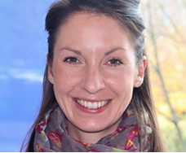
Alex Anslow
Alex is Dance City’s Artistic Programmes Producer. Alex’s role is to support, develop and implement high quality theatre programming opportunities for professional dance artists and other related forms for Dance City. Alex advocates for, supports and champions Dance and Dance Artists working and living in the North East of England. She supports and develops the professional artists support programme, including the performance programme in Dance City and beyond.
Alongside working at Dance City Alex works as a freelance Event Manager at major outdoor arts festivals across the region including Festival of Thrift and Lumiere Durham. Alex graduated from York University with a BA Hons in History of Art and is a Postgraduate of Northumbria University with a Masters in Cultural Event and Conference Management.

Stella Hall

Stella Hall, FRSA, has a passion for connecting people and place through culture. She co-founded the Green Room, Manchester, was Director, Warwick Arts Centre and Festival Director, Belfast Festival at Queen’s. As Deputy Director, NGI, she led the Culture¹⁰ programme across the North East.
She was Festival Director of Preston Guild 2012 and in 2013 co-founded the hugely popular Festival of Thrift, the National Festival of Sustainable Living. In 2020 it won the People, Environment, Achievement Award, for its digital Festival.
Stella is a board member of D6:EU and Rosie Kay Dance, and a Council Member of Queen Mary University.
She is a committed internationalist and has advised and learnt from cultural organisations in Eastern Europe, India, China, Turkey, Kazakhstan and Uzbekistan. Alongside culture and placemaking consultancies she regularly mentors younger professionals.

  - Commissioning Panel

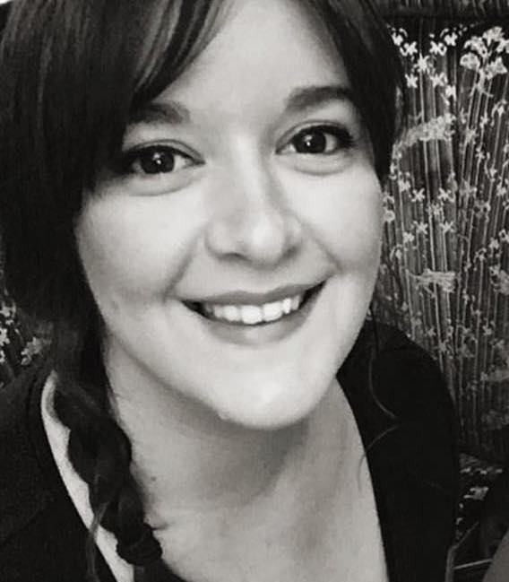
Maddie Maughan
Maddie is an independent creative producer with over 15 years of experience based in the North East of England.
Working primarily in the realm of outdoor arts events, from intimate to large scale, Maddie produces work that takes over spaces in the public realm – entire cities; parks and old buildings; and the communities where people live. She works with artists to bring to life creative experiences that transform the everyday into the extraordinary.
Maddie’s work to date has included practical and strategic delivery of a range of successful projects, including large-scale outdoor performance events, music festivals and arts festivals, as well as installation-based works and more intimate and durational projects catering to audiences from all backgrounds. She has been involved in a range of high-profile projects such as Hull UK City of Culture 2017, Lumiere Durham, Newcastle’s London 2012 Olympic Games cultural programme, Great North Run Million Opening Ceremony and Great Exhibition of the North.
Maddie is Lead Producer for Festival of Thrift, working with the Festival team and artists to ensure successful delivery of the creative programme.

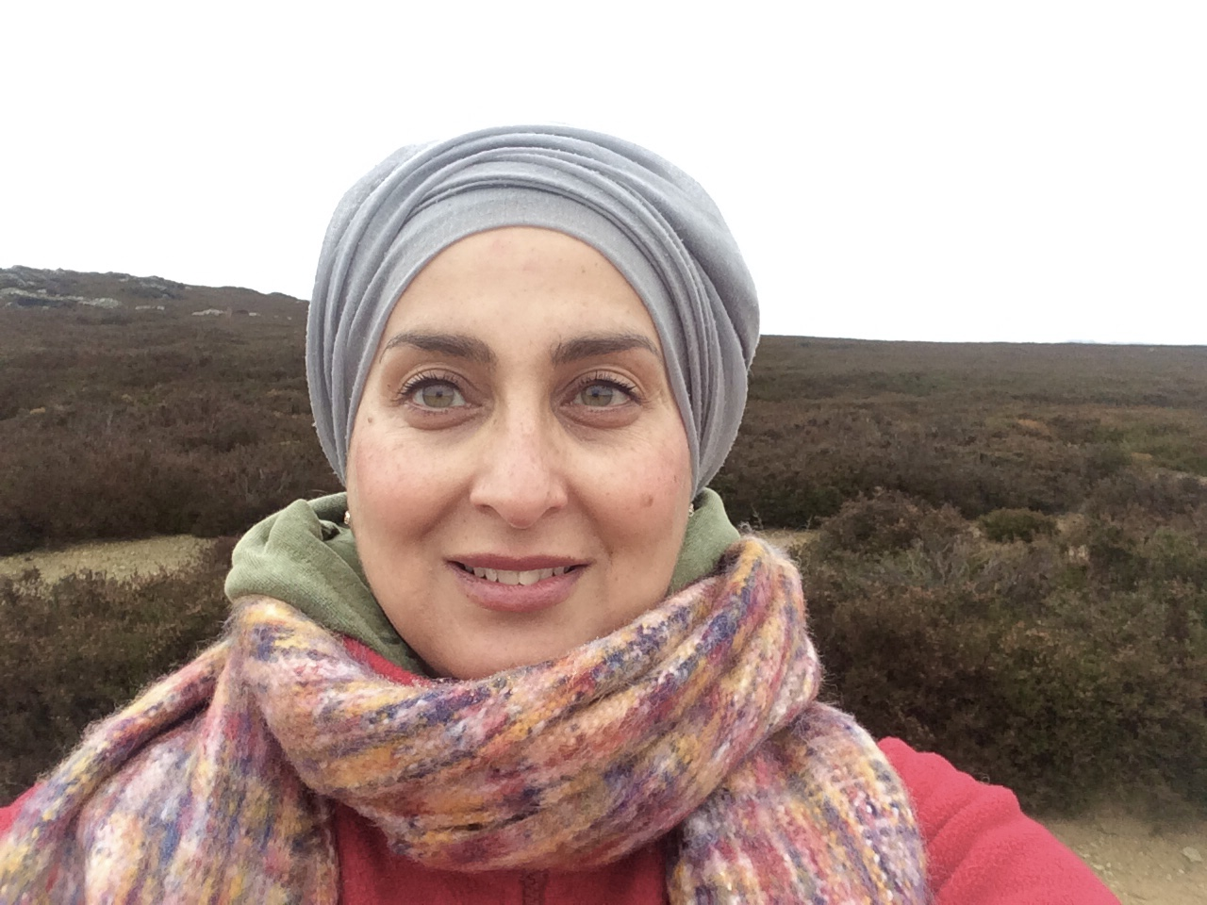
Shahda Khan
Director of Borderlands, Creative People & Places Programme (based in Middlesbrough and Redcar & Cleveland). Shahda has a substantive portfolio of delivering multi-disciplinary programmes, which has involved working with a wide range of communities, especially those from underrepresented groups as well as strategic partners. A significant part of this work involved facilitating community led initiatives. She is founding member of ITV’s Tyne Tees Diversity Panel, a former Governor both of Middlesbrough College and Teesside University. She independently advises and leads projects with national government(s), US Embassy in London, MoD as well as community organisations.

