Dance City EASY READ
Outdoor Commission with Nexus 2021
Dance City
Dance City is a place where people, both the public and professionals, go to socialise, learn new skills, keep fit and active, train professionally and find out more about dance. Established for over 30 years Dance City is the North East’s leading development organisation for dance.

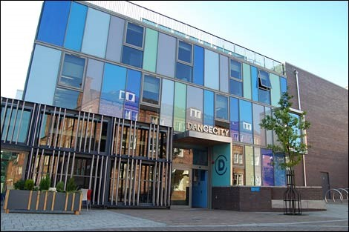

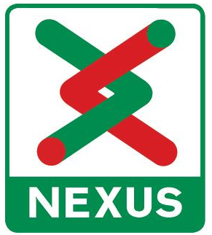
Nexus

Nexus is the public body which owns and runs the Tyne and Wear metro, as part of its role to provide local transport in the region. It supports a longstanding programme of public arts partnerships and commissions.

Dance City have been reviewing their commissioning process, and want to make it more inclusive and accessible to all forms of dance work, including outdoor work – taking dance to where our communities meet. We hope this opportunity is appealing to artists across the region who want to make work with Dance City and our valued partners, networks and audiences.



In 2020 Tyne and Wear Metro celebrated its 40th anniversary – having carried over 1.5 billion people since it opened in 1980. Delayed due to the pandemic, the Metro Takeover 40th Anniversary Project is a programme of cultural activities to mark this special occasion throughout 2021 and into 2022. You can find out more here - https://www.nexus.org.uk/metro/40years



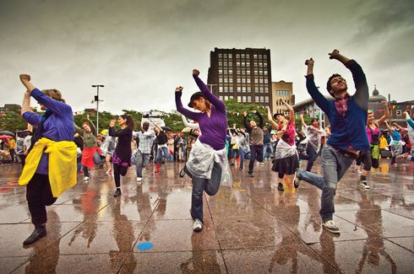
The opportunity

Dance City would like to commission (to offer money, studio space and resources) a professional dance artist (makers/ choreographers), to create an outdoor dance work.

The commission value is £4,000 cash (including VAT). This money must include all artist fees, collaborator fees, materials, costume, set, props, technical equipment hires, transport, travel, accommodation and subsistence costs for you to make this work.

Make sure this is clear in the budget you send to us with your application.

For this project to be realised to its full potential we invite you to explore additional funding and other partners. Dance City will support you with approaching partners and funding applications.



The following support in kind will also be made available to the successful artist/company:
- X 1 day technical support, plus complimentary use of our small in-house, portable sound system to be used on performance dates.
- Marketing support via Dance City, Nexus and project partners networks.
- X 2 weeks of studio space at Dance City

Mon 23 Aug – Fri 27 Aug, 9am – 5pm, Dance City Newcastle studios
Tues 31 Aug – Fri 3 Sept, 9am – 5pm, Dance City Sunderland studios

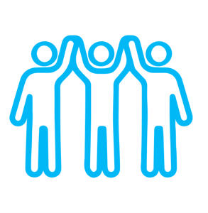


The performance dates are:

Thurs 2 September
Fri 3 September
Sat 4 September
Sun 5 September

The Brief
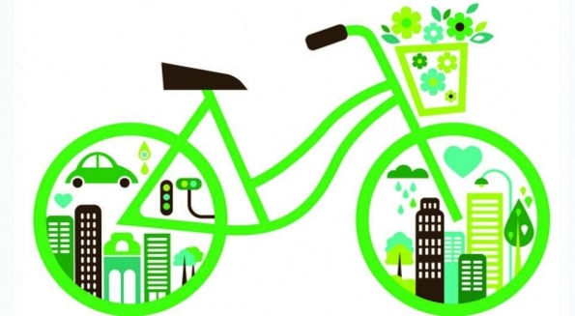
We expect the commissioned artist/company to consider themes of sustainable transport and travel, and environmental themes.


We want to encourage and inspire audiences to rethink how they travel to different places. How can they use public transport more? How can we have fewer cars on the road, and therefore less pollution?

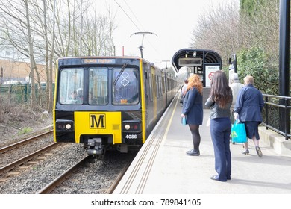
The Metro Takeover themes are heritage and community, and we’d like to see the journey of passengers brought to life through movement – their behaviors, mannerisms, and sharing of space.

You must:
- Be making a new work that is in the early stages of the making process. The work cannot already exist or be re-worked for this commission.
- Specialise in dance or physical theatre, and this must be the main style of the work, but we welcome you to work with other artists too.
- Create work that is to a professional standard and features professional artists.
- Create a work that is a minimum of 5-10mins, which can be repeated at multiple sites.
- Be based, from, trained or living in the North East.
- Have experience in making outdoor work.
- Have experience applying for funding for arts/cultural projects
- Create a work that is flexible, adaptable to all weathers, and safe to perform in public spaces as this is a live transport network with passengers.
- Attend meetings with the Dance City & Nexus teams – dates TBC

You can:
- Create either a solo, duet or group work
- Be either an individual dance artist or a company, or perhaps you’d like to apply in collaboration with another dance company and/or artists from another discipline.
- Use any style or genre of dance in your work.
- Include non-professional performers alongside the professional cast if you like.

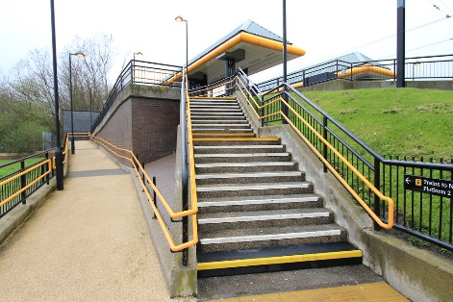



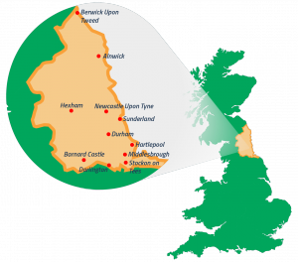

Key Considerations


We welcome proposals which include an element of community engagement or participation. This could either be:
- Online
- Remotely
- In a way which follows social distancing measures
For marketing purposes, creative approaches to documenting the making process of the work to be shared with both commissioners and through marketing activity is expected.

We know that making new dance work during a pandemic is different and challenging. We still want to find ways to successfully create work, safely and with adaptations if needed. You should think about:
· Creating, rehearsing and delivering your work using social distancing guidelines if necessary
· Making sure your work is accessible to those with disabilities
We are seeking creative ideas that are high quality, engaging and accessible, but also challenging and thought provoking.
Reconnecting our communities after the pandemic restrictions is a priority aim for the network, and this essence should be reflected within the artistic themes.

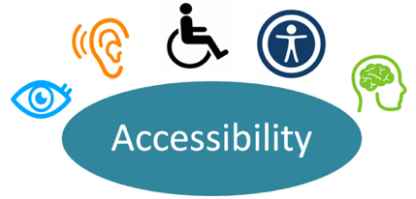




Artists are responsible for:
- Planning the number of performances possible during the event
- Providing a Risk Assessment, including COVID-19 safety measures
- Their own Public Liability Insurance
- Seeking permissions and music licences

Timeline

Proposal Deadline | Friday 2 July – 12noon
Shortlisting Stage One applications | Monday 5 - Friday 9 July
Artists notified of outcome | Monday 12 July
Stage Two – Interviews (via Zoom) | Wednesday 14 July (a £30 stipend (inc VAT) is paid to artists unsuccessful at interview, paid by BACS upon receipt of an invoice)
Artists notified of outcome | Thursday 15 July

How to Apply
To apply for this new commission opportunity, please respond to the questions below.

If you have any access requirements and need support with the application process, please contact us.

Written applications must be submitted via email.

We also accept applications in video or sound recording format. We can arrange a face-to-face meeting with one of our team which constitutes a verbal application. Please submit all formats via email to Alex Anslow – alex.anslow@dancecity.co.uk





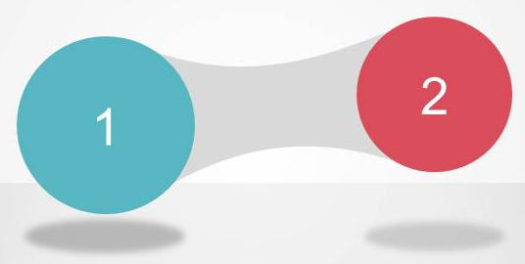
The application process is in two stages:
- Stage 1 - Expression of Interest (Written/ Video Application)

- Stage 2 – Interviews (via Zoom)

The panellists include Alex Anslow from Dance City, Stella Hall from Festival of Thrift and Lynn Dickinson from Nexus, plus more to be announced.



We actively encourage applications from artists who self-identify as Black, Asian, ethnically diverse, Lesbian, Gay, Bisexual, Transgender, Queer, d/Deaf, neurodiverse or disabled.


Deadline

Please submit your application by Friday 2 July 2021, 12noon.


Please complete the equal opportunities monitoring form. The information will help us monitor the fairness and effectiveness of our selection processes and identify barriers to selection. Your answers will be kept strictly confidential and used for statistical monitoring purposes only; they will not be seen by the panel.

Commission Two Application Form
Please provide as much detail as possible
Full Name
Postcode
Email
Telephone
How did you hear about the Commission?

Stage One – Written/Video Application
- Please tell us about your recent artistic work, experience, and achievements. (250 words)
(Artistic interests, style and inspiration for your work. What have you previously made?)
- What experience do you have making outdoor or site-specific work? (250 words)
- What is your artistic concept for the Commission? (300 words)
(Please describe the idea for your artistic work)
- What is your commitment / connection to the North East? (150 words) (Do you live, or did you train here? How will you contribute to the development of the dance sector?)
- Please outline how you might engage the public in the making of this work. Does the work have opportunities for engagement? If yes, please tell us more (250 words)
- Please provide any links to your work
(videos (max 2), images (max 10), reviews (max 2), testimonials (max 2), audience feedback (max 2), websites (max 1).)
- Which other trusts/foundations/funders are you approaching to financially support the creation of this work? (150 words) (We encourage you to use the commission money to leverage further support for your work from other sources)

- Do you have any producing or mentoring support for this project? (250 words) (If so, please include their details below. If not, please outline who you would like to work with, or if your project is self-produced please tell us your experience and expectations for this project)

- Please attach a budget overview, in excel format. This should include the full costs of the project, including the commission funds. (max 1 page)

- Please briefly summarise the support Dance City has offered you/your company during your career. (max 250 words) (e.g commission, performance date, studio space, staff time, equipment loan, office space etc)

- Please detail your current or prospective creative team (e.g dramaturg, costume designer, producer etc) (150 words)
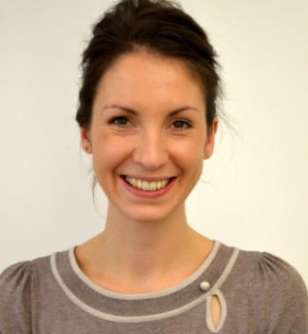
We are happy to offer a 15min informal conversation with one of our Artistic Team prior to you submitting your application, if you feel this would be beneficial. Please email alex.anslow@dancecity.co.uk to arrange a suitable date and time.
Please email the completed form/video to Alex with Dance City Metro Takeover Commission 2021 in the subject line, by 12 noon, Friday 2 July at 12noon.
(Applications submitted after this date will not be considered)

