  - Dance City
  - Outdoor Commissions 2021

  - 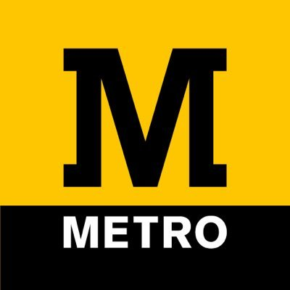

  - Dance City is commissioning a new site responsive work by dance makers/choreographers from the North of England, in partnership with Nexus and Arts Council England. As the only regional commissioning body for dance, we have been reviewing our commissioning process and would like to make it more inclusive and accessible to all forms of dance work, such as live stage performances, outdoor work, and dance film. We are constantly striving to find new ways to support exciting new choreography, and we hope this Outdoor Commission opportunity appeals to artists across the region who want to create work with Dance City and its valued partners, networks and audiences.

  - This is the second commission announcement as part of our new Outdoor Commissions programme.

TIMELINE

Deadline | Friday 2 July – 12noon
Shortlisting Stage 1 applications by panel | Monday 5 - Friday 9 July
Artists notified of outcome | Monday 12 July
Stage Two – Interviews (via Zoom) | Wednesday 14 July
Artists notified of outcome | Thursday 15 July

Stipends:
Stage One - No stipend
Stage Two - £30 stipend for artists unsuccessful in being awarded a commission at the interview stage, for time preparing for and attending their interview.
(The above amounts are including VAT, and paid by BACS upon receipt of an invoice.)

  - Commission Panel

  - Alex Anslow

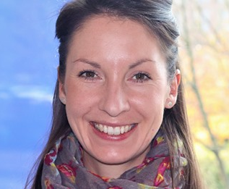
Alex Anslow is a Producer, Programmer and Events Manager working in the North East Cultural Sector. Alex has worked at Dance City, Newcastle UK, in various roles for 11 years and is currently the Producer there. Work has included working closely with the Artistic Director to programme high quality, professional performances that challenge, inspire and entertain audiences. It has included working as part of a vibrant Artistic Team to develop the professional artist development programme placing North East artists at the heart of it, as well as curating visual art exhibitions at Dance City to increase the footfall of the venue to a wider audience. Alongside working at Dance City Alex works as a freelance Event Manager for arts festivals across the region including Festival of Thrift, Enchanted Parks, Gateshead International Festival of Theatre and Lumiere Durham. When the opportunity arises Alex also works as a freelance Producer for independent dance artists/companies. Alex graduated from York University with a BA Hons in History of Art and is a Postgraduate of Northumbria University with a Masters in Cultural Event and Conference Management.

  - Stella Hall

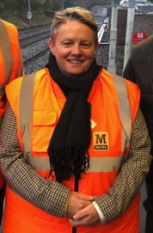
Lynn Dickinson

Lynne is the Metro Operations Station Manager and is responsible for the 60 stations that make up the Metro system and around 120 people who work on them. Her team make sure Metro is a safe, welcoming and safe environment, with art and performance playing one part in that. She brings years of experience in how passengers behave and use the space of stations. Lynne lives with her family in South Tyneside and commutes to work daily on Metro herself.

  - With more panelists to be confirmed.

  - Partner Information

  - NEXUS

  - 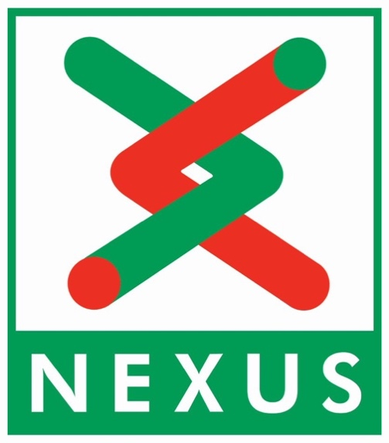

Metro’s 40th Anniversary Takeover Project
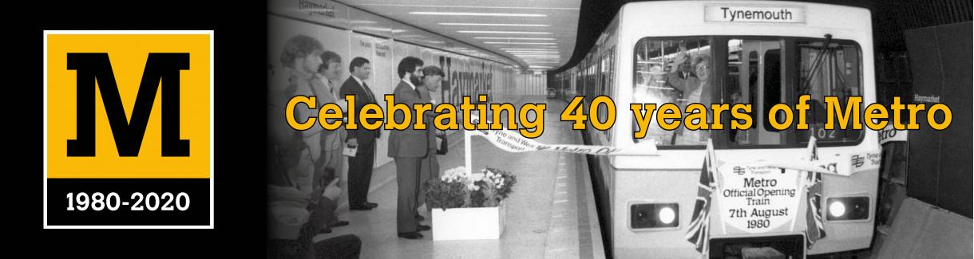

In 2020 Tyne and Wear Metro celebrated its 40th anniversary – having carried over 1.5 billion people since it opened in 1980.

Nexus is the public body which owns and runs the Tyne and Wear Metro, as part of its role to provide local transport in the region. It supports a longstanding programme of public art partnerships and commissions of which the Metro Takeover project is the latest part, taking Nexus and Metro into the realm of dance and theatre on stations for the first time.

You can find out more about the broader programme of events here - https://www.nexus.org.uk/metro/40years

  - DANCE CITY
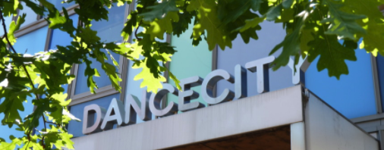
Established for over 30 years Dance City is the North East’s leading development organisation for dance, which exists to lead and support a thriving dance ecology in the region. We present a regular programme of dance performances from contemporary to ballet, world to breakdance bringing leading North East, British and International dance to Newcastle. We also commission original new works, which premiere in our theatre and beyond. Our vision is to ensure that the North East is the best place to be a professional dance artist. Our mission is to provide excellent training, support, networking and funding opportunities for North East professional dance/movement artists.

Commission Two - Dance City & Nexus
Dance City and Nexus are commissioning one dance artist/company to create a new outdoor work for the festival in 2021. Dance City’s team have an exemplary track record in commissioning and programming indoor dance works. Through this commission, we are looking to broaden our reach to connect with more artists, audiences and places across the region, by taking dance outside of our purpose-built facilities to spaces where our communities meet. We are delighted to be partnering with Nexus to co-commission this new aspect of our collective offer for the region.

The project budget available for this commission is £4,000 (inc VAT). For this project to be realised to its full potential we invite you to explore additional funding and other partners. Dance City will support you with approaching partners and funding applications.

We expect the commissioned artist/company to consider themes of sustainable transport and travel, and environmental themes which could encourage and inspire audiences to rethink their modes of transport to become more public and less dependent on private car ownership. The Take Over themes are heritage and community, and we’d like to see the journey of passengers brought to life through movement – their behaviours, mannerisms, and sharing of space. Reconnecting our communities after the pandemic restrictions is a priority aim for the network, and this essence should be reflected within the artistic themes.

Commission Two Rehearsal Dates:
Monday 23 August – Friday 27 August, 9am – 5pm, Dance City Newcastle studios
Tuesday 31 August – Friday 3 September, 9am – 5pm, Dance City Sunderland studios

Commission Two Performance Dates:
Thursday 2 September – Sunday 5 September

Key Considerations

- The commissioned work will be performed at various stations on the Nexus Tyne and Wear Metro network. Performance locations and available technical aspects TBC. Proposed Metro stations include Tynemouth, Newcastle Central, Gateshead International and Park Lane. Additional stations may be considered in negotiation with Nexus and subject to further Risk Assessment. You will have to be very flexible in your approach as this is a live transport network with passengers.
- The work can be any style of dance or movement. It can be a solo, duet or group work.
- The work must be of a professional standard and feature professional artists. Non-professional performers are welcomed in addition to the cast.
- We expect the work to be a minimum of 5-10mins. The work will need to be versatile and mobile so it can easily be performed repeatedly to audiences as they arrive on site.
- You are expected to attend meetings and site visits ahead of the creation weeks. Dates and times TBC.
- The commissioned artist/company is required to keep a journal of their journey in the development of their practice, their relationship with others, any quotes, issues and ‘magic moments’. Aspects of this content are to be shared publicly.
- Please consider accessibility in regards to the work you propose to present. All spaces identified to be used for the performances must have good sightlines and be accessible to everyone.
- We are interested in opportunities for participation and engagement. Please consider your offer to local communities when applying for this commission.
- You must have your own Public Liability Insurance.
- You will need to submit a Risk Assessment for your work, for approval by Dance City and the Nexus team. All health and safety guidance provided by Nexus must be adhered to at all times.
- Please note that although studio space will be provided for the work to be made indoors, all performances will take place outdoors and therefore practical and logistical considerations must be factored into the creative process. This includes health and safety for performers and audiences and contingencies for adverse weather conditions. Ideally performances do not require static set-ups of props, PA and dance floor, as performances will occur in multiple spaces and times throughout the day. The commissioned artist will also need to agree to adhere to all covid safety restrictions.
- The artist/company is responsible for seeking all permissions and licenses for music used, and gaining correct approval from PRS, including paying any royalties due
- Nexus will be providing full marketing and promotional support or Metro Takeover, including £10,000+ spend and the services of its award-winning in-house marketing, PR and design team.

Eligibility
Artist/Company must:
- Be based, from, trained or living in the North of England.
- Be makers of dance or physical theatre work of any genre. Circus arts are not eligible for this opportunity.
- Have a track record in making outdoor or site-specific/site responsive work.
- Have a commitment to developing work, partnerships and audiences within the region on a medium to long term basis.
- Have experience of applying to other funders in order to attract additional resources to realise this project.

We are looking for new work or work currently at an early stage of Research & Development. Re-imagined or already completed works are not eligible.

Project summary
Metro Takeover will be the core of the ‘Community’ theme in these celebrations, alongside separate Nexus and external projects looking at Heritage and the Future.

Takeover will use arts commissioning to place our communities at the heart of celebrations and reflect on life today in our region using Metro as both showcase and reference point. It will offer people from a wide spectrum a unique opportunity to create, display, perform and share new work on stations and trains over a 40-day period from summer 2021 through to spring 2022. The overall programme will cover stations in Newcastle, Sunderland, Gateshead, North Tyneside and South Tyneside.

Public Engagement
Metro Takeover is designed to engage across a wide range of the community, with examples including:
- Young people aged 11-18 in North Tyneside through workshops and a drama project with Stage.
- School pupils and young people aged 7-11 in Newcastle and North Tyneside through a collaboration with Little Inventors.
- Carers, choir members aged 60+ in learning and performing new song.
- Curious Festival storytelling performances for families to highlight our LGBTQ community.
- Multi-cultural communities in and around the Byker Wall in Newcastle.
- Engagement in devising, developing and participating in a visual arts workshop programme with Cultural Spring CPP in Jarrow and South Shields.
- Cross-cultural workshop projects engage young Asian voices, older residents and refugees with Sunderland Culture.
- Metro staff.
Reaching new audiences
COVID restrictions allowing, Metro will be used by approximately 4.5 million passengers during the Takeover, who will be exposed to direct opportunities to view as they travel or marketing about the programme.

_________________________________________________________

Commission Two Budget
Successfully commissioned artist/company will receive:
- £4,000 -The commission total is inclusive of all artists fees, collaborator fees, materials, costume, set, props, technical equipment hires, transport, travel, accommodation, and subsistence costs associated with the work, so your initial indicative budget will need to demonstrate this.

The following support in kind will also be made available to the successful artist/company:
- X1 day technical support, plus complimentary hire of our small in-house, portable sound system to be used on performance dates.
- Marketing support via Dance City, Nexus and project partners’ networks.
- X 2 weeks of studio space at Dance City Newcastle/Sunderland, Mon – Fri 9am – 5pm.

