Dance City EASY READ
Outdoor Co-Commission with Festival of Thrift

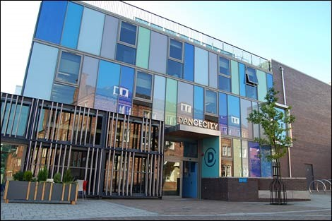
Dance City
Dance City is a place where people, both amateur and professionals, go to socialise, learn new skills, keep fit and active, train professionally and find out more about dance.
Established for over 30 years Dance City is the North East’s leading development organisation for dance.
Dance City has two venues.
We have our purpose-built dance house in Newcastle upon Tyne city centre.
We also have two studios based at The Fire Station in Sunderland city centre.

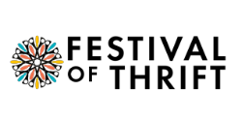

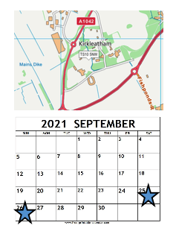
Festival of Thrift
Festival of Thrift is based in Redcar, on the North East coast, and is the UK’s national festival of sustainability. A family friendly festival, it positions artists as inspirers, encouraging change through a free programme of workshops, exhibitions and performances.
The festival celebrates the joys of a climate-friendly way of life. It takes place in Kirkleatham, near Redcar and will return in 2021 on:
Saturday 25 & Sunday 26 September.

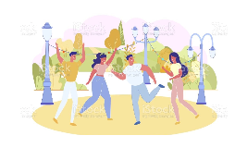

Dance City and Festival of Thrift are inviting one dance/physical theatre artist/company to create a new outdoor work for Festival of Thrift 2021.

The commission value is £8,000 cash (including VAT). This fee must include all artist fees, collaborator fees, materials, costume, set, props, technical equipment hires, transport, travel, accommodation and subsistence costs for you to make this work.

Make sure this is clear in the budget you send to us with your application.


The Brief
Artists are asked to respond to the themes of ‘future sustainability’ and/or water. You can interpret the meaning of these themes any way you like.
The theme of this year’s festival is water, and this festival is at the same time as the first ‘Year of the English Coast’ which explores issues such as rising sea levels due to climate change, water pollution, water safety and reducing water use.
The panel are keen to see proposals that link with this year’s theme and explore ideas creatively. Ideas must be high quality, engaging and accessible, as well as challenging and thought provoking.



Dance City and Festival of Thrift are committed to reducing their carbon footprint. This means reducing the total greenhouse gas emissions caused by the Festival and other activity.
We’d like to see proposals for performances which do not need to use lots of, or any, energy or power.
We’d also like you to think about how to reduce your travel distances using environmentally friendly transport, as well as sustainable options for your set, props and costumes.

so are expectant of proposals which take into consideration the most sustainable and low energy formats of working.



Eligibility
You must:
- Be making a new work that is in the early stages of the making process. The work cannot already exist or be re-worked for this commission.
- Specialise in dance or physical theatre, and this must be the main style of the work, but we welcome you to work with other artists too.
- Create work that is to a professional standard and features professional artists.
- Be based in the UK.
- Create a work that is no longer than 30mins.

You can:
- Create either a solo, duet or group work
- Be either an individual dance artist or a company, or perhaps you’d like to apply in collaboration with another dance company and/or artists from another discipline.
- Use any style or genre of dance in your work.
- Include non-professional performers alongside the professional cast if you like.





Key Considerations

We welcome proposals which include an element of community engagement or participation. This could either be:
- Online
- Remotely
- In a way which follows social distancing measures
We would welcome creative approaches to documenting the making process of the work to be shared with both commissioners and through marketing activity if appropriate.

An illustrated plan of the festival site can be found here.
You may wish to undertake your own site visit in advance of submitting a proposal, but this will be at your own expense.
We are interested in applications which are site specific/sympathetic.



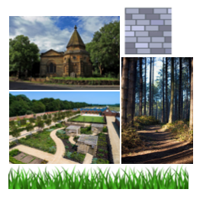
We encourage artists to consider where they would like their work to be sited. Kirkleatham, has a variety of sites including:
- Grass areas
- Roads, paving and car parks
- An enclosed stable block
- Woodlands
- Church yard

Please tell us where you’re thinking of presenting your work in your application proposal.

We know that making new dance work during a pandemic is different and challenging. We still want to find ways to successfully create work, safely and with adaptations if needed. You should think about:
· Creating, rehearsing and delivering your work using social distancing guidelines if necessary
· Making sure your work is accessible to those with disabilities
We are seeking creative ideas that are high quality, engaging and accessible, but also challenging and thought provoking.

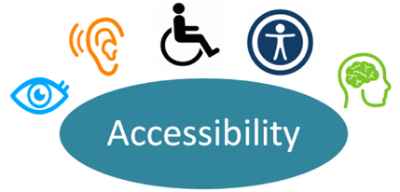



Festival of Thrift attracts very large audiences, approximately 35,000-40,000 people during the two-day event. It’s very popular with families with young children.

Please think carefully about how a large, standing audience will have the best experience of your work, such as sight lines and hearing any audio. Also think about how many times you can perform your work during the weekend.

The festival will continue even if the weather is bad, so your performance needs to be adaptable and safe to perform in all weathers. Only in really severe weather will it be cancelled.

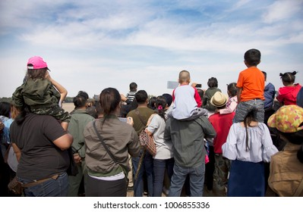


Artists are responsible for:
- Planning the number of performances; the festival is open from 10am – 5pm
- Providing a Risk Assessment, including COVID-19 safety measures
- Their own Public Liability Insurance
- Seeking permissions and music licences

Support available
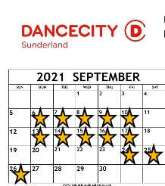
Dance City and Festival of Thrift will provide the following support:
- Two weeks of studio space in Dance City Sunderland from 6-10 September and 13-17 September
- Producer support throughout the creation of your work
- Technical support for the rehearsal, install and get-out during Festival of Thrift
- Marketing support via Dance City and Festival of Thrift
- A technical rehearsal onsite during Friday 24 September
- Local advice on community engagement from Festival of Thrift



Timeline
Proposal Deadline | 12noon, Friday 2 July
Shortlisting Stage One applications | Monday 5 June – Friday 9 July
Artists notified of outcome | Monday 12 July
Stage Two – Interviews (via Zoom) | Wednesday 14 July (a £30 stipend (inc VAT) is paid to artists unsuccessful at interview, paid by BACS upon receipt of an invoice)
Artists notified of outcome | Thursday 15 July

How to Apply

To apply for this new commission opportunity, please respond to the questions below.

If you have any access requirements and need support with the application process, please contact us.

Written applications must be submitted via the online portal - https://docs.google.com/forms/d/e/1FAIpQLSdv5_38QLhmXSaWdrSaHpcwdt2KWITZLU8DGuVk2P-0EyWDoQ/viewform?usp=sf_link

We also accept applications in video or sound recording format. We can arrange a face-to-face meeting with one of our team which constitutes a verbal application. Please submit these formats via email to Alex Anslow – alex.anslow@dancecity.co.uk



We actively encourage applications from artists who self-identify as Black, Asian, ethnically diverse, Lesbian, Gay, Bisexual, Transgender, Queer, d/Deaf, neurodiverse or disabled.


Deadline

Please submit your application by Friday 2 July 2021, 12noon.


Please complete the equal opportunities monitoring form. The information will help us monitor the fairness and effectiveness of our selection processes and identify barriers to selection. Your answers will be kept strictly confidential and used for statistical monitoring purposes only; they will not be seen by the panel.

Application Questions
1. Please tell us about your recent artistic work, experience, and achievements.
(250 words)
For example, your artistic interests, style, and inspiration for your work. What have you previously made?
2. What experience do you have making outdoor or site-specific work? If none, please identify what you see as the key differences. (250 words)
3. What is your artistic concept for the Commission? (300 words)
Please describe the idea for your artistic work.
4. Describe the site that you would like the work to be presented in (150 words)
This can be the ideal type of location (e.g., level hard standing, on grass, amongst trees, a particular dimension of performance area, etc.), or a particular site you have identified.
5. What attracted you to this opportunity? (150 words)
6. Please outline how you might engage the public in the making of this work. Does the work have opportunities for engagement? If yes, please tell us more (250 words)
7. Do you have any producing or mentoring support for this project? (250 words)
If so, please include their details below. If not, please outline who you would like to work with, or if your project is self-produced please tell us your experience and expectations for this project.
8. Please detail your current or prospective creative team (e.g dramaturg, costume designer, producer etc) (150 words)
9. Supporting Materials (max. 5 files)
Please provide us with materials in support of your proposal - these may include examples of previous work, reviews, testimonials, designs, sketches or mood boards for of the proposed work, biography/CV, or anything else you think will support your proposal. Files can include images, video, sound files or documents (including Word, PDF, PowerPoint, Excel). Maximum 10mg per file.
10.Please attach a budget overview, in excel format. This should include the full costs of the project.
If you have any access requirements and need support with the application process, please contact Alex Anslow at Dance City: Alex.Anslow@dancecity.co.uk
We are happy to offer a 15min informal conversation with one of our Artistic Team prior to you submitting your written/video application, if you feel this would be beneficial. Please email alex.anslow@dancecity.co.uk to arrange a suitable date and time

Please note that the delivery of Festival of Thrift 2021, and therefore this commission is dependent on the successful outcome of an Arts Council England Project Grant, which is currently being assessed. The outcome is likely to be received at the end of June.

  - Commissioning Panel

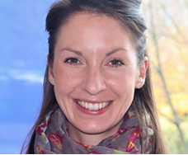
Alex Anslow
Alex is Dance City’s Artistic Programmes Producer. Alex’s role is to support, develop and implement high quality theatre programming opportunities for professional dance artists and other related forms for Dance City. Alex advocates for, supports and champions Dance and Dance Artists working and living in the North East of England. She supports and develops the professional artists support programme, including the performance programme in Dance City and beyond.
Alongside working at Dance City Alex works as a freelance Event Manager at major outdoor arts festivals across the region including Festival of Thrift and Lumiere Durham. Alex graduated from York University with a BA Hons in History of Art and is a Postgraduate of Northumbria University with a Masters in Cultural Event and Conference Management.

Stella Hall

Stella Hall, FRSA, has a passion for connecting people and place through culture. She co-founded the Green Room, Manchester, was Director, Warwick Arts Centre and Festival Director, Belfast Festival at Queen’s. As Deputy Director, NGI, she led the Culture¹⁰ programme across the North East.
She was Festival Director of Preston Guild 2012 and in 2013 co-founded the hugely popular Festival of Thrift, the National Festival of Sustainable Living. In 2020 it won the People, Environment, Achievement Award, for its digital Festival.
Stella is a board member of D6:EU and Rosie Kay Dance, and a Council Member of Queen Mary University.
She is a committed internationalist and has advised and learnt from cultural organisations in Eastern Europe, India, China, Turkey, Kazakhstan and Uzbekistan. Alongside culture and placemaking consultancies she regularly mentors younger professionals.

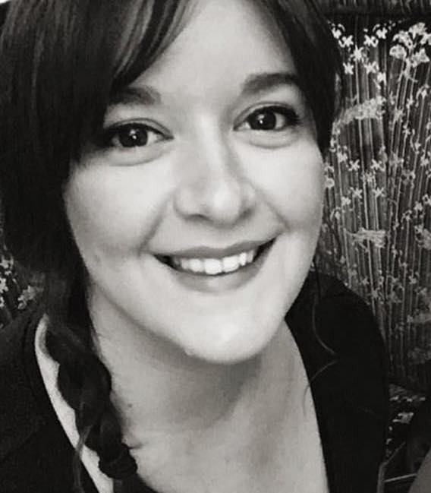
Maddie Maughan
Maddie is an independent creative producer with over 15 years of experience based in the North East of England.
Working primarily in the realm of outdoor arts events, from intimate to large scale, Maddie produces work that takes over spaces in the public realm – entire cities; parks and old buildings; and the communities where people live. She works with artists to bring to life creative experiences that transform the everyday into the extraordinary.
Maddie’s work to date has included practical and strategic delivery of a range of successful projects, including large-scale outdoor performance events, music festivals and arts festivals, as well as installation-based works and more intimate and durational projects catering to audiences from all backgrounds. She has been involved in a range of high-profile projects such as Hull UK City of Culture 2017, Lumiere Durham, Newcastle’s London 2012 Olympic Games cultural programme, Great North Run Million Opening Ceremony and Great Exhibition of the North.
Maddie is Lead Producer for Festival of Thrift, working with the Festival team and artists to ensure successful delivery of the creative programme.

