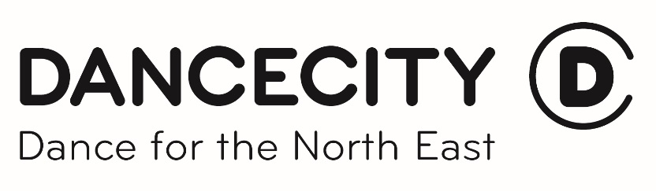

Expanding Horizons 2016/17 Application Form

Name

Address

Mobile Number | E-Mail Address
Qualifications

Courses

Brief background of your work/ yourself as an artist/maker. (max. 200 words)

What is it you think you need to do to move your career up a level?
(max. 200 words)

What ideas do you have for a self-directed project that would support this career development?
(max. 200 words)

Please tell us of any commitments from September 2016 – July 2017 which may affect your availability to attend Expanding Horizons sessions.

Is there anything else you think we should know?

Thank you

Please return this form to Chloe Stott by Monday 3rd October either in writing to Chloe Stott, Dance City, Temple Street, Newcastle Upon Tyne, NE1 4BR or by email to chloe.stott@dancecity.co.uk.

