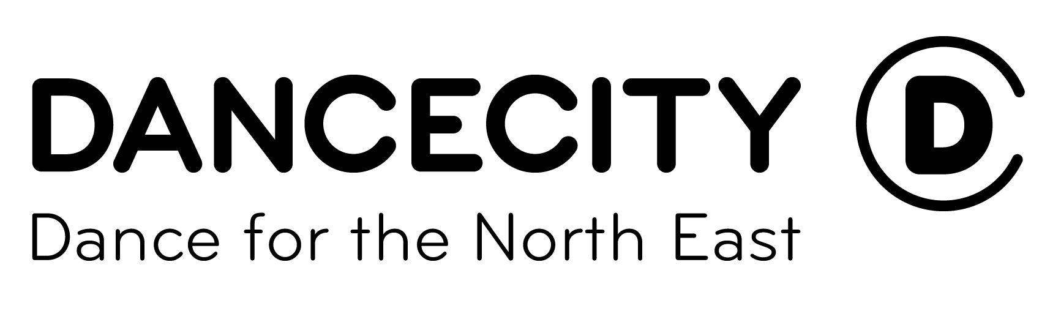
Perform in PULSE 2017

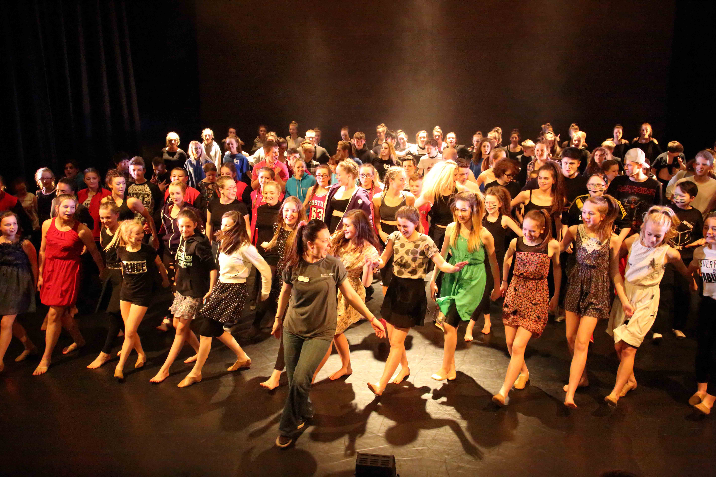

Celebrating Dance across the North East and as part of a National event.
Dear Dance Supporter
Re: PULSE 2017 and Dance City Sub-Regional Pulse Platform

In order to support groups who actively promote and develop dance work, I write to inform you of PULSE 2017. PULSE is a series of events that celebrate the best in youth dance across the region and provide groups (schools and community) with the opportunity to perform in a professional space local to them, be inspired, see each other’s work and acknowledge the talent of young creators and performers.

The PULSE 2017 Sub-Regional Platforms also offer the opportunity of youth dance progression routes; groups of young people aged 11 to 19 (and disabled young people up to the age of 24) can opt to be part of a selection process to represent the North East at the Dance City Regional Pulse Platform which follows the Pulse events and then at National level as U.Dance 2017 hosts a celebration festival in Birmingham in July.

At each of the Sub Regional events (from groups who have ‘opted in’) we will select two to perform at Dance City’s Regional Pulse Platform and from this event we will select a further two to represent the North East in Manchester in July. These stages are purely optional and groups may opt to perform at their sub regional event only if they wish (see dates below). We are especially keen to receive applications from groups which include disabled dancers and are working to ensure the festival is inclusive and fully accessible.

PULSE events are happening throughout the North East region in Feb/March 2016 and for the opportunity to be involved please complete the attached ‘confirmation of interest form’ and email directly to your nearest platform organiser by Fri 25th Nov 2016.

Each platform organiser will compile all the responses and then contact you in December with further details and to ask you for the relevant information about your group and pieces, please make sure you adhere to deadlines.
Pulse > U.Dance progression chart.
U.Dance 2017 Birmingham July

Regional Pulse event at Dance City for selected groups, two final groups selected to represent the North East at U.Dance.
Sub regional Pulse events take place throughout the North East in Feb/March 2017 and two groups from each venue will be selected.

The aims of Pulse include to:
- Develop relationships between Dance City, Dance Hubs and other youth dance groups/ schools
- Provide a platform for groups to celebrate their achievements in dance
- To bring groups together in a unique and special event
- To raise aspirations
- To enhance and inform dance practice
- To enable the young people to represent their group and instil a sense of pride and achievement irrespective of ability
- To actively encourage cooperation and participation between groups
- To provide an opportunity for progression pathways into a National Event if desired

Pulse Performance Dates and contact details (please send the completed form to your nearest platform organiser directly using the email info below):

Dance City: Newcastle/Gateshead groups. Sun 5th March holly.irving@dancecity.co.uk

Berwick Maltings Northumberland Groups. Sat 12th March milevadonachie@me.com

Customs House: North and South Tyneside Groups. Tues 14th March
daniel@customshouse.co.uk

ARC: Tees Valley groups Sat 11th March
Amy.Mitchell@StocktonArtsCentreARC.onmicrosoft.com

Tin Arts: Durham Groups. Sunday 19th March
Martin@tinarts.co.uk

Arts Centre Washington: Sunderland Groups. Sat 25th March
Rachel.Hamer@sunderland.gov.uk

Dance City Regional Pulse Platform (for 2 selected groups from each area only).
Sun 2nd April.

‘Pathways into Pulse’

This year there are two new pathways to Pulse festival: New Dimensions and National Choice. Please see the guidance notes to apply.

National event U.Dance 2017 in Birmingham 13th-16th July (for selected groups only–please ensure you go to www.u.dance.org and read the Application Guidance Notes for this before opting in to this stage). Please note: For groups that are wishing to be considered for the U.Dance National event 2017, groups are to be made up of no more than 20 dancers (it is recommended that groups comprise of no more than 15 dancers as groups of 16 dancers or more will need to have three chaperones instead of two) and dance pieces are to be no longer than 7 minutes. There will be a cost of approx. £145 per dancer for this stage to be involved in the 3 day festival.

Please keep these dates and info to hand and contact the relevant platform organiser if you have any enquiries. We look forward to receiving your completed confirmation of interest forms by Fri 25th Nov and hope you are as enthusiastic as we are about this exciting opportunity.

Yours sincerely
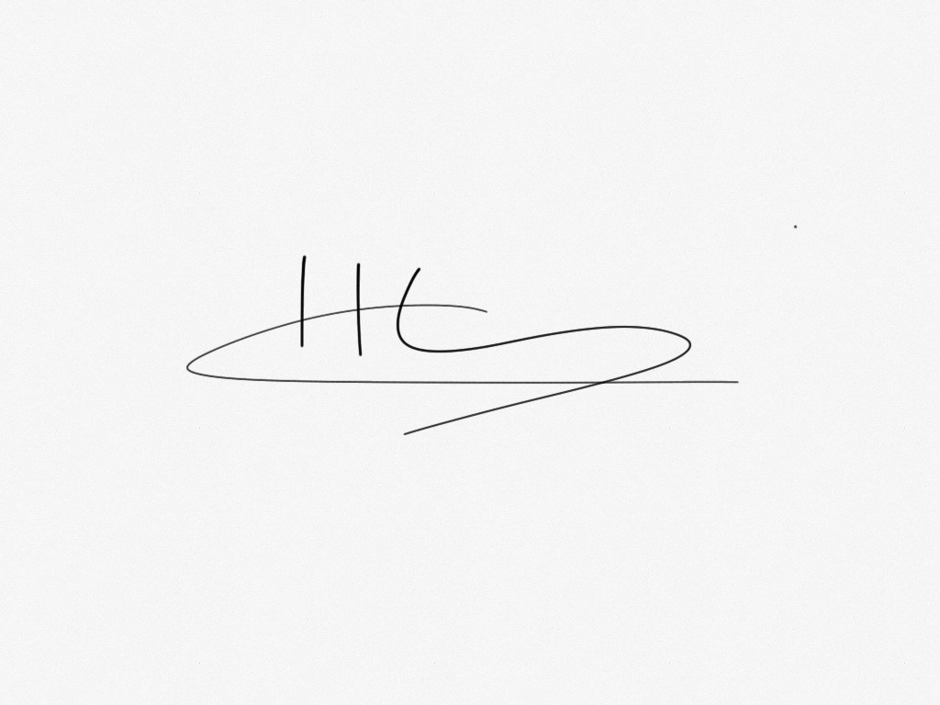

Holly Irving

Dance Engagement Coordinator, Dance City

Pulse 2017– Confirmation of interest for Sub-Regional Platforms
Name of Group
Name of Group Leader
Correspondence address  (Group Leader) | Address:  Postcode:
Telephone Number
Mobile Phone Number
Email Address
Website

Please specify which Pulse event you would like to be involved in (by highlighting the relevant date) AND highlight YES if you would like to be considered for selection for Regional and National events. PLEASE NOTE: The area in which you live will determine which Pulse event you should perform in and you should send this completed form directly to the contact below no later than Fri 25th Nov or you will not be considered for performance. Many thanks for your support.

Pulse Performance Dates

Dance City: Newcastle/Gateshead groups. Sunday 5th March
holly.irving @dancecity.co.uk

Berwick Maltings: Northumberland Groups. Sat 12th March milevadonachie@me.com

Customs House: North and South Tyneside Groups. Tues 14th March daniel@customshouse.co.uk

Tin Arts: Durham Groups. Sun 19th March
Martin@tinarts.co.uk

Arts Centre Washington: Sunderland Groups. Sat 25th March
Rachel.Hamer@sunderland.gov.uk

ARC: Tees Valley groups.
Christopher.Goodyear@arconline.co.uk

Would you like to be considered for selection to perform at the Dance City Regional Pulse Platform? (Sun 2nd April) Please highlight if YES

Would you like to be considered for selection to perform at U.Dance 2017 in Birmingham (July 8-10th) (please note that there will be additional costs per dancer at around £120 to be involved at this National level and in order to be selected for this event, you must also be selected to perform at the Dance City Regional Pulse Platform event on 2nd Apr). Please read all the info of what is involved at www.u.dance.org

Please highlight if YES



Pulse 2017

Celebrating Youth Dance across the North East

Are you part of a youth dance group?

Are you 11 - 19 years old? Or up to 25 for inclusive groups?
Would you like the chance to perform in an exciting venue in the North East? and even represent the North East at a national dance event? Then Pulse 2016 is for you!

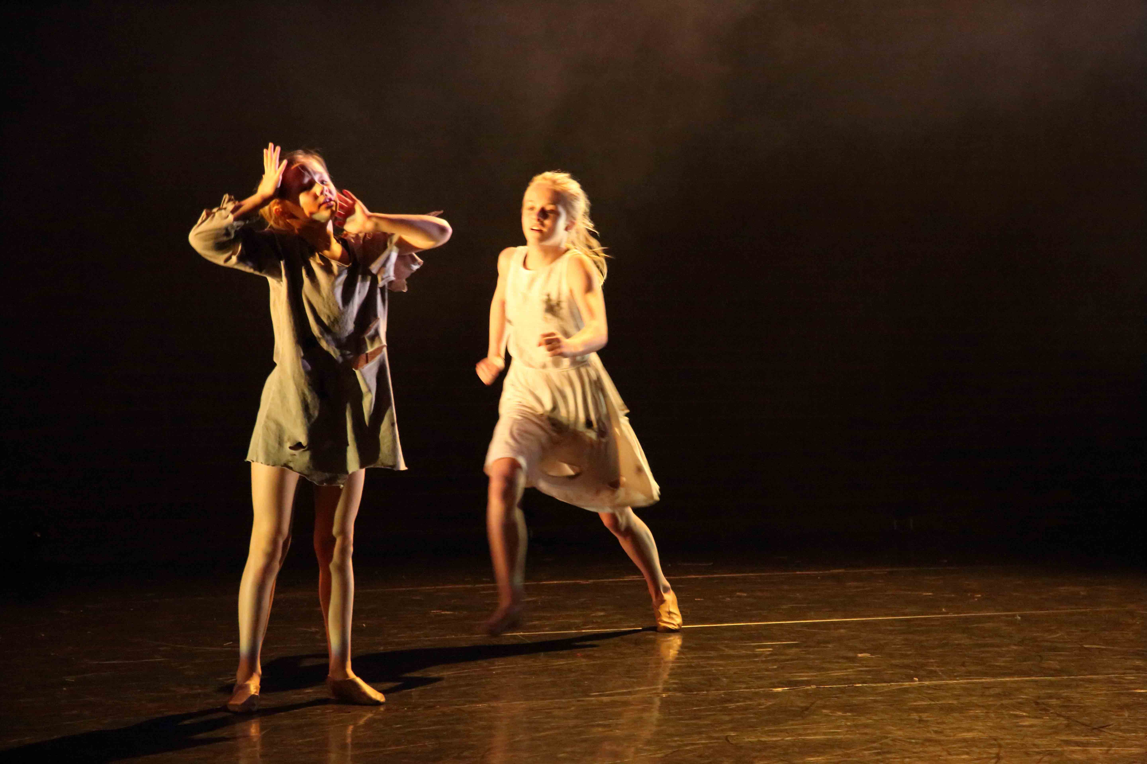

For more details of how to get involved with Pulse 2017 visit www.dancecity.co.uk or contact Holly Irving: holly.irving@dancecity.co.uk
Deadline end of Nov!

