We would like to invite you to take part in Dance City’s newest performance platform…

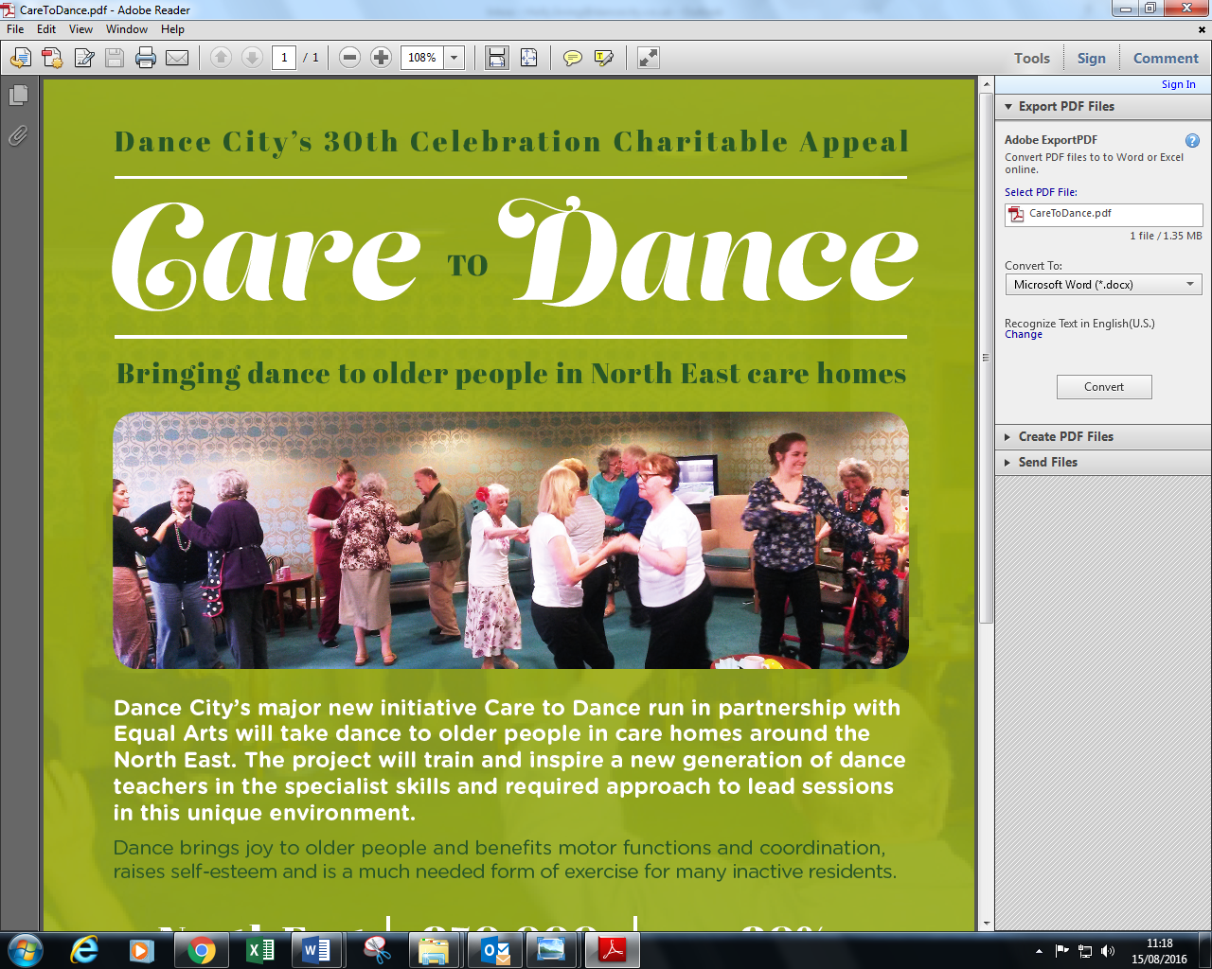

Celebrating dance for over 55’s and beyond!

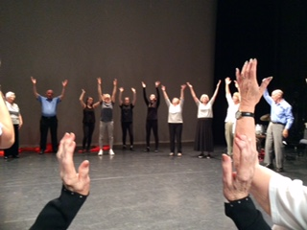

Date: Sat 30th Sep

In order to support groups who actively promote and develop dance work for and with over 55’s, I write to invite you to perform in our Care to Dance platform 2017. An opportunity to celebrate dance, perform in a professional space, be inspired and share each other’s work. Join us for the first platform which we hope will become an annual event.

Timings: Technical rehearsal on the day (tbc for each group)

Dress rehearsal 4pm-5.15pm

Performance 6.30pm – in Dance City’s main theatre. Tickets will be on sale for the general public.

Please fill out the confirmation of interest form below or pass onto anyone you think would be interested and return to [helen.kumar@dancecity.co.uk](mailto:helen.kumar@dancecity.co.uk) before Friday 30th June.

Best wishes



Helen Kumar, Dance Engagement Coordinator

Care to Dance Platform Sat 30th Sep 2017 – Confirmation of interest

|  |  |
| --- | --- |
| **Name of Group** |  |
| **Name of Group Leader** |  |
| **Correspondence address**  (Group Leader) |  |
| **Telephone Number** |  |
| **Mobile Phone Number** |  |
| **Email Address** |  |
| **Website** |  |