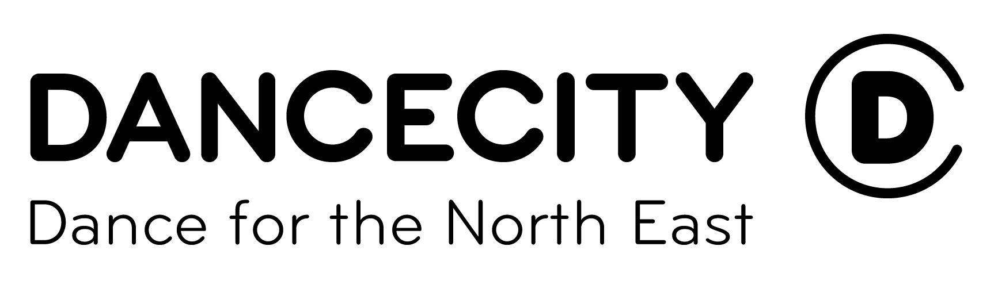
Perform in PULSE 2018
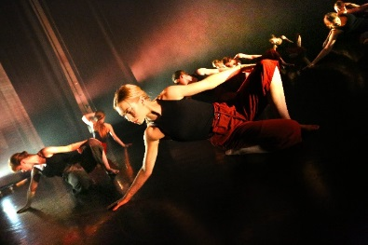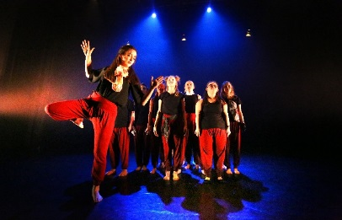

Celebrating dance across the North East, and as part of a National event.
Dear Dance Supporter
Re: PULSE 2018 and Dance City Sub-Regional Pulse Platform

I am writing to inform you about PULSE 2018, a series of events that celebrate the best in youth dance across the region. It provides groups (schools and community) with the opportunity to perform in a professional space local to them, be inspired, see each other’s work and acknowledge the talent of young creators and performers.

The PULSE 2018 Sub-Regional Platforms also offer progression route opportunities; groups of young people aged 11 to 19 (and disabled young people up to the age of 24) can opt to be part of a selection process to represent the North East at the Dance City Regional Pulse Platform which follows the Pulse events and then at National level as U.Dance 2018 hosts a celebration festival in Surrey in July.

At each of the Sub Regional events (from groups who have ‘opted in’), one or two are selected to perform at Dance City’s Regional Pulse Platform and from this event a National Panel select a further one to represent the North East in July. These stages are purely optional and so groups can use the sub regional event as just a performance platform if they wish to (see dates below). We are especially keen to receive applications from groups which include disabled dancers and are working to ensure the festival is inclusive and fully accessible.

For the opportunity to be involved please complete the attached ‘confirmation of interest’ form’ and email directly to your nearest platform organiser by Fri 10th Nov 2017.

The aims of Pulse are to:
*Develop relationships between Dance City, Dance Hubs and other youth dance groups/ schools
*Provide a platform for groups to celebrate their achievements in dance
*To bring groups together in a unique and special event
*To raise aspirations
*To enhance and inform dance practice
*To enable the young people to represent their group and instil a sense of pride and achievement irrespective of ability
*To actively encourage cooperation and participation between groups
*To provide an opportunity for progression pathways into a National Event if desired

‘Pulse’ part of U.Dance Progression Chart.
U.Dance 2018 Surrey

Regional Pulse event at Dance City (Sat March 17th) for selected groups, one final group selected to represent the North East at U.Dance.
Sub regional Pulse events take place throughout the North East in Feb/March 2018 and two groups from each venue will be selected to perform at the Regional event at Dance City.
Each platform organiser will compile all the responses and then contact you in December with further details and to ask you for the relevant information about your group and pieces, please make sure you adhere to deadlines.

Pulse Performance Dates and contact details
(Please send the completed form to your nearest platform organiser directly using the email info below):

Sub regional platforms:
Customs House, South Shields Tue 6th February DClifford@customshouse.co.uk
Arts Centre, Washington – Sat 24th Feb emily.corney@sunderland.gov.uk
Dance City, Newcastle Sat 3rd March helen.kumar@dancecity.co.uk
Tin Arts, Durham Sun 4th March martin@tinarts.co.uk
Arc, Stockton Sat 10th March Jenni.Salkeld@arconline.co.ukk
Queens Hall Arts Centre Sun 11th March milevadonachie@me.com

Regional platform: (for selected groups only) Dance City Sat 17th March helen.kumar@dancecity.co.uk

National event U.Dance 2018 in July (for selected groups only)–please ensure you go to www.u.dance.org and read the Application Guidance Notes for this before opting in to this stage). Please note: For groups that are wishing to be considered for the U.Dance National event 2018, groups are to be made up of no more than 20 dancers (it is recommended that groups comprise of no more than 15 dancers as groups of 16 dancers or more will need to have three chaperones instead of two) and dance pieces are to be no longer than 7 minutes. There will be a cost of approx. £145 per dancer for this stage to be involved in the festival.

We look forward to receiving your completed confirmation of interest forms by Fri 10th Nov and hope you are as enthusiastic as we are about this exciting opportunity.
Yours sincerely, Helen Kumar, Dance Engagement Coordinator, Dance City
Pulse 2018– Confirmation of interest for Sub-Regional Platforms
Name of Group
Name of Group Leader
Correspondence address  (Group Leader) | Address:  Postcode:
Telephone Number
Mobile Phone Number
Email Address
Website

Please specify which Pulse event you would like to be involved in (by highlighting the relevant date) AND highlight YES if you would like to be considered for selection for Regional and National events. PLEASE NOTE: The area in which you live will determine which Pulse event you should perform in and you should send this completed form directly to the contact below no later than Fri 10th Nov or you will not be considered for performance. Many thanks for your support.

Pulse Performance Dates
Sub regional platforms:
Customs House, South Shields Tue 6th February DClifford@customshouse.co.uk
Arts Centre, Washington – Sat 24th Feb emily.corney@sunderland.gov.uk
Dance City, Newcastle Sat 3rd March helen.kumar@dancecity.co.uk
Tin Arts, Durham Sun 4th March martin@tinarts.co.uk
Arc, Stockton Sat 10th March Jenni.Salkeld@arconline.co.ukk
Queens Hall Arts Centre Sun 11th March milevadonachie@me.com

Regional platform: (for selected groups only) Dance City Sat 17th March helen.kumar@dancecity.co.uk

Would you like to be considered for selection to perform at the Dance City Regional Pulse Platform? (Sat 17th March) Please highlight if YES

Would you like to be considered for selection to perform at U.Dance 2018 in Surrey (July(please note that there will be additional costs per dancer at around £145 to be involved at this National level and in order to be selected for this event, you must also be selected to perform at the Dance City Regional Pulse Platform event on 17th March). Please read all the info of what is involved at www.u.dance.org

Please highlight if YES

Pulse 2018

Celebrating Youth Dance across the North East

Are you part of a youth dance group?

Are you 11 - 19 years old? Or up to 25 for inclusive groups?
Would you like the chance to perform in an exciting venue in the North East? and even represent the North East at a national dance event? Then Pulse 2018 is for you!

For more details of how to get involved with Pulse 2018 visit www.dancecity.co.uk or contact helen.kumar@dancecity.co.uk
Deadline end of Nov!

