Meet, dance, and perform
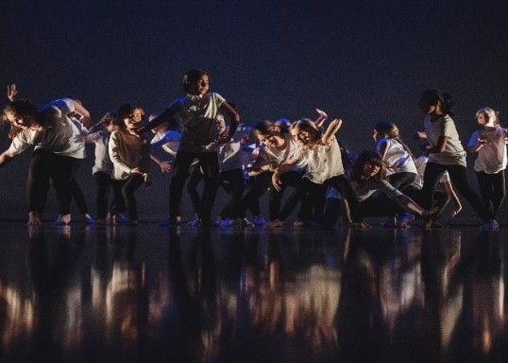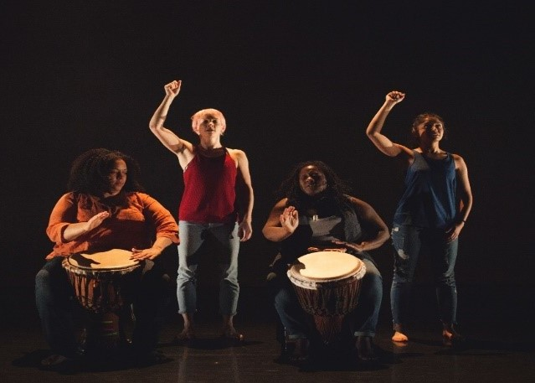
_______________________________________________________________________________

Dance City are hosting the first ‘Unity Dance Platform’ and welcome dance groups of all ages: 7+ to adult in any style to come and perform in our theatre.
Saturday 2 June 2018
If you have a dance group already, that is great, or if you are a group of people who would like to dance – we can work with you at your venue to create a new piece.
We are on your doorstep and we want to welcome you in. We are looking for groups who are based in and around Newcastle/ Gateshead who have never danced on our stage before.
Please contact helen.kumar@dancecity.co.uk , Dance Engagement Coordinator
Dance City, Temple Street, Newcastle Upon Tyne, NE1 4BR, 0191 2695576

Confirmation of interest for Unity Platform June 2nd 2018
Name of Group
Name of Group Leader
Correspondence address
(Group Leader)
Telephone Number
Mobile Phone Number
Email Address
Info about the group

