PULSE 2019: A celebration of children and young people’s dance across the North East

PULSE 2019 offers a chance for dancers to perform and share their work at a professional local venue.
It is part of U.Dance (www.onedanceuk.org) – a national programme supporting and encouraging dance and performance opportunities for young people across the country.

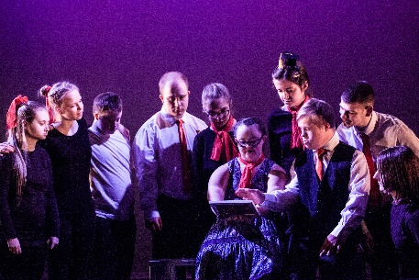
Read on if you have a dance group who would love to:
- perform in a professional local venue
- be inspired by watching other groups perform
- take part in celebrating the talent of young dancers
- have the chance to perform in a National Event representing the North East

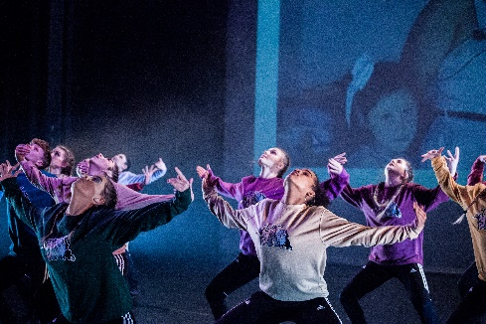
To take part in PULSE your group must be aged 11 – 19
(or up to and including age 24 for dancers with a
disability)

Watch our video to find out more:
https://youtu.be/eoojSe1yZK0
How to take part
To take part in the first round of PULSE – the ‘Sub-regional’ - at a venue near you, simply complete the attached registration form and return it by Friday 9th November to your closest venue and we will contact you with more information.

If you choose to, each group who performs at a Sub-regional event has the chance to progress to take part in a Regional event and then at U.Dance National event in London.
Sub-regional PULSE Events:
Perform at your local
Sub-regional PULSE event
You can perform just for fun or opt to be part of the selection process - up to 2 groups per event are chosen to take part in the Regional
Tees Valley: Thurs 31 Jan debbie@thedproject.co.uk
Sunderland: Sat 16 Feb sheree.rymer@sunderlandcollege.ac.uk
Northumberland: Sun 17 Feb milevadonachie@me.com
North/South Tyneside: Mon 25 Feb izzy@customshouse.co.uk
Newcastle/Gateshead: Sat 2 Mar helen.kumar@dancecity.co.uk
Durham: Sat 2 March jo@tinarts.co.uk

If your group is interested in continuing, you may be invited to perform at the Regional event. Pieces chosen to progress will celebrate and represent the breadth and depth of dance work created and performed by young people. The work will demonstrate the potential to reach excellence in performance standards.
Sunday 24th March 2019 Gala Theatre, Durham
Perform at your local
Regional PULSE event

2 groups from the Regional are chosen to take part in the U.Dance National event in London

If your group is interested in continuing, you may be invited to perform at the U.Dance National Final Event. Two pieces from each Regional event across the country will be chosen by the U.Dance National Judging Panel.
Perform at U.Dance
National Final Event

All groups must:
- Have no more than 20 dancers
- Have a piece no longer than 7 mins
- Raise approx. £150 per dancer to take part

20th – 21st July 2019

London

We hope you are as excited as we are about this fantastic opportunity!
To get involved please complete the attached registration form and email directly to your nearest Sub-regional organiser by Fri 9th November 2018 (contact email addresses are at the top of this page). Feel free contact us if you have any questions.

