Call out for Dance City commissions is now open!
Dance City is seeking applications from dance artists/companies from across the North East to apply for our annual Commission programme which will support up to 8 artists/companies to develop new dance work from an overall budget of up to £24,000.
There are 3 commission strands available:
- Full Production
- Early Stage Production
- Charlotte Grant Early Career Artist Award
We recommend that you read the guidance carefully to ensure you select the most appropriate strand for your work.
Please only apply for one commission strand, per work, artist/company
All strands are open to artists/companies (not NPOs), regardless of whether you’ve applied for or received a commission from us previously. Across the 3 commission strands we are particularly looking to support artists who identify as Lesbian, Gay, Bisexual, Transgender, Queer+, Black, Asian, Minority, Ethnic/People Of Colour, Disabled and mature (10 years plus of professional practice), the latter an area highlighted by sector consultation. We define dance in this context as all styles and genres of movement focused work, including aerial and circus arts.
All strands welcome artists/companies who are producing a full-length live performance, film or outdoor dance work. Any film work is to be in accordance with Arts Council England’s definition, ‘creative films that involve artists working in our supported artforms and where film is the medium for their work.’
The commission period is January 2020 – December 2021. Commission funds will be released in installments from April 2020, to be discussed with Dance City.
This commissioning programme is exclusively for artists who are from, who studied at undergraduate level or above, or who are based or working in the North East of England. The lead applicant must show their connections and commitment to developing the North East dance sector.
Dance City commissions are as follows:
- Full production:
This opportunity is for artists/companies who are producing a full-length live performance, film or outdoor dance work (minimum of 50 minutes in length)
Up to 3 artists/companies will be awarded up to £5,000 each
Please note, only up to one grant could be awarded for a full-length film or outdoor dance application.
Each artist/company will receive:
- A date in Dance City’s Professional Performance Programme 2020-2022 if appropriate. Alternative platforms can be discussed with Dance City’s programming staff.
- Five days of in-kind studio space in either our Newcastle or Sunderland studios (depending on availability). In-kind value up to £1,000 per week.
- Marketing advice, support and consultancy specific to this work (for example, could consist of, social media support and promotion opportunities, and up to eight hours of Marketing and Audience Development advice). In-kind value up to £1,000.
- Up to 10 hours of producing support specific to this work. In-kind value up to £500.
- Up to one meeting with the Technical Manager, one full production day in the Theatre in Newcastle in advance of the performance and one performance day in the theatre. In-kind value up to £2350.
- Up to 20 days of free hot-desking space in our new ‘Co-Working Hub’ in Newcastle. In-kind value up to £400.
- Up to eight hours of free access to our meeting room facilities in Newcastle. In-kind value up to £200.
- Potential opportunity to have your commission piece and experience digitally documented online. In-kind value up to £500.

Total in-kind value for full commissions: up to £5,950.

The commissioned artist/company agrees to:
- Offer a minimum of two professional classes at our Newcastle venue as part of our morning Pro Class offer to local professional dance artists
- Offer a minimum of one opportunities for local professional artists/companies to access open rehearsals/talks/workshops/informal sharing’s
- Offer a minimum of one opportunity for audiences to experience their work/rehearsal/process
- Attend meetings with the Dance City team to evaluate progress
- Deliver an engagement activity or post-show discussion with the audience after the performance at Dance City
- Take part in Dance City’s documentation and promotion of the Dance City commission’s programme. Supply images and copy when requested and in response to deadlines.

- Early Stage Production:
This commission is for development of early stage work - a live dance performance, film or outdoor dance work (5 – 15 minutes in duration)
Up to 3 artists/companies will be offered up to £2,000 each
Please note, only up to one grant could be awarded for an Early Stage Production film or outdoor dance application.
Each artist/company will receive:
- A performance slot in Dance Edits Programme September 2020 if appropriate for the work produced. Other platform opportunities can be discussed with Dance City programming staff.

- One week of in-kind studio space in either our Newcastle or Sunderland studios (depending on availability). In-kind value up to £1,000.

- Up to three hours of marketing support specific to this work (for example, could consist of, social media support, self-marketing pack, audience advice and support promotional opportunities via Dance City marketing channels). In-kind value up to £400.
- Up to three hours of producing support specific to this work. In-kind value up to £150.
- Up to three hours of technical support specific to this work. In-kind value up to £185.
- Up to five days of free hot-desking space in our new ‘Co-Working Hub’ in Newcastle. In-kind value up to £100.
- Up to 4 hours of free access to our meeting room facilities in Newcastle. In-kind value up to £120.
- Potential opportunity to have your commission piece and experience digitally documented online. In-kind value up to £500.
Total in-kind value for Early Stage commission: up to £2,455

The commissioned artist/company agrees to:
- Offer a minimum of 1 professional class at our Newcastle venue as part of our morning Pro Class offer to local dance artists
- Offer a minimum of 1 opportunity for local professional artists/companies to access open rehearsals/talks/workshops/informal sharing’s
- Offer a minimum of 1 opportunity for audiences to experience their work/rehearsal/process
- Attend meetings with the Dance City team to evaluate progress
- Take part in Dance City’s documentation and promotion of the Dance City commission’s programme. Supply images and copy when requested and in response to deadlines.

- Charlotte Grant Early Career Artist Award:
This commission strand is kindly supported by the Charlotte Grant legacy donation gifted by her family, and supported using public funding by Arts Council England, match funded by the Catalyst Fund. This commission strand is created in memory of Charlotte who trained and developed her professional career here at Dance City, and generously pays forward this opportunity for more artists to follow in her footsteps.
This commission is to support recent BA or MA graduates who have graduated in the last three years and who are from, who live and/or who have trained at undergraduate level or above in the North East of England.
There are two opportunities for commissions to develop early stage work - a live dance performance, film or outdoor work (5 – 15 minutes in duration)
Up to two artists will receive a commission of up to £1,500 each
At least one of the commissioned pieces will be a live performance to be showcased in Dance City’s theatre.
Each graduate will receive:
- A performance slot in Dance Edits Programme September 2020 if appropriate for the work produced. Other platform opportunities can be discussed with Dance City programming staff.

- Five days of in-kind studio space in either our Newcastle or Sunderland studios (depending on availability). In-kind value up to £1,000.

- Up to three hours of marketing support specific to this work (for example, could consist of, social media support, self-marketing pack, audience advice and support promotional opportunities via Dance City marketing channels). In-kind value up to £400.
- Up to three hours of producing support specific to this work. In-kind value up to £150.
- Up to three hours of technical support specific to this work. In-kind value up to £185.
- Up to five days of free hot-desking space in our new ‘Co-Working Hub’ in Newcastle. In-kind value up to £100.
- Up to four hours of free access to our meeting room facilities in Newcastle. In-kind value up to £120.
- Potential opportunity to have your commission piece and experience digitally documented online. In-kind value up to £500.
Total in-kind value of Charlotte Grant commission: £2,455

The commissioned artist/company agrees to:
- Offer a minimum of one opportunity for local professional artists/companies to access open rehearsals/talks/workshops/informal sharing’s
- Offer a minimum of one opportunity for audiences to experience their work/rehearsal/process
- Attend meetings with the Dance City team to evaluate progress
- Take part in Dance City’s documentation and promotion of the Dance City commission’s programme. Supply images and copy when requested and in response to deadlines.

Dance City Newcastle – Theatre
Our Theatre is an extremely versatile space, with 240 brand new seats, raked across two levels providing unrestricted views throughout the auditorium. The lower section of the rake is retractable to accommodate cabaret or smaller scale performances and events.
We also have four dressing rooms complete with shower and toilet facilities. A full lighting rig and sound system are in situ and we can also screen films on the large white cyclorama at the back of the space.
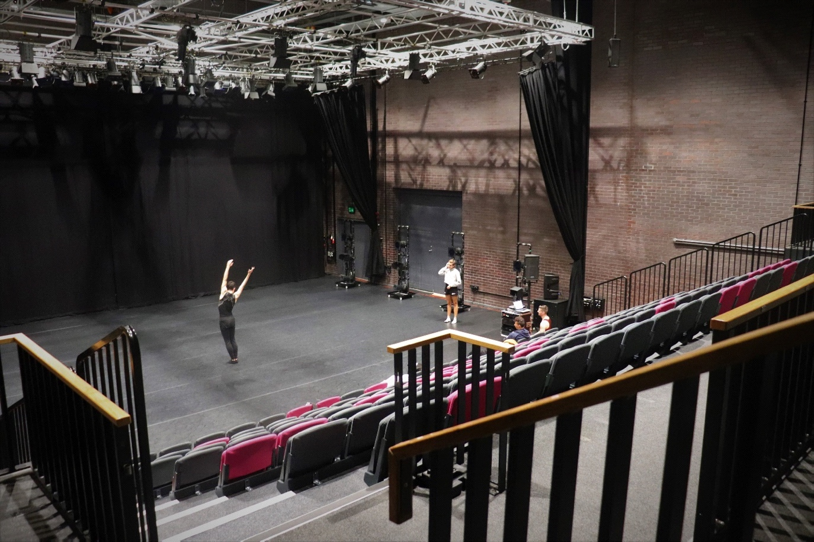
(Image credit: Pippa Kyle, artists featured Eliot Smith Dance)

Technical Specification, click on this link: https://www.dancecity.co.uk/wp-content/uploads/2019/10/Dance-City-Tech-Spec-July-19-1.pdf

For information on how to apply, please click here. (link to website)
For a video to Dance City Commissions information including BSL interpretation, click here. Available week commencing 4 November.
For an easy read version of the Dance City Commissions information click here.

Overall Guidelines
- We wish to see evidence that you have considered producer support, mentoring support, and evidence of how your proposed activity will contribute to the dance sector.
- Please outline which other sources of funding you are exploring to support this application. We encourage you to leverage further funding from this commission from other funders, venues and partners.
- The work can be tailored towards small, medium or large scale across each of the 3 strands.
- Please note that costs and management to mount or install outdoor work is the responsibility of the applicant. Evidence of Licenses, Permits and Risk Assessments for the work must be available on request. Dance City can offer support and advice if required.
- Technical specifications for film work must be budgeted for in the artist’s application. Dance City can offer to support with equipment from our in house facilities, but additional hires must be covered by the applicant.

