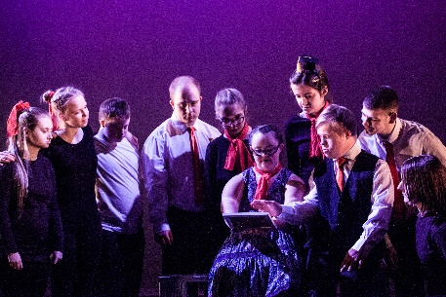
PULSE 2020 offers a chance for dancers to perform and share their work at a professional local venue.

It is part of U.Dance (www.onedanceuk.org) – a national programme supporting and encouraging dance and performance opportunities for young people across the county.

Read on if you have a dance group who would love to:
- perform in a professional local venue
- be inspired by watching other groups perform
- take part in celebrating the talent of young dancers
- have the chance to perform in a National Event representing the North East
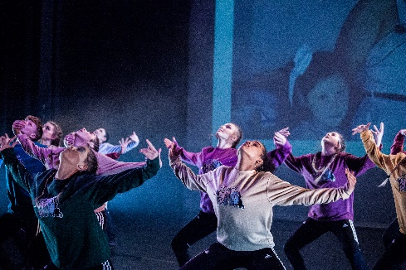
To take part in PULSE your group must be aged 11 – 19
(or up to and including age 24 for dancers with a
disability)
How to take part:
To take part in the first round of PULSE – the ‘Sub-regional’ - at a venue near you, simply complete the attached registration form and return it by Friday 8th November to your closest venue and we will contact you with more information.

If you choose to, each group who performs at a Sub-regional event has the chance to progress to take part in a Regional event and then at U.Dance National event in Glasgow.

Sub-regional PULSE Event:
Tees Valley: Tues 28th Jan debbie@thedproject.co.uk
Sunderland: Mon 17th Feb lauren.robinson@sunderlandcollege.ac.uk
Northumberland: Sun 29th Feb milevadonachie@me.com
North/South Tyneside: Mon 10th Feb izzy@customshouse.co.uk
Newcastle/Gateshead: Sat 15th Feb helen.kumar@dancecity.co.uk
Durham: Sun 8th March jo@tinarts.co.uk

If your group is interested in continuing, you may be invited to perform at the Regional event. Pieces chosen to progress will celebrate and represent the breadth and depth of dance work created and performed by young people. The work will demonstrate the potential to reach excellence in performance standards.

Perform at your local
Regional PULSE event

2 groups from the Regional are chosen to take part in the U.Dance National event in London
Saturday 14th March
Dance City, Newcastle

If your group is interested in continuing, you may be invited to perform at the U.Dance National Final Event. One piece from each Regional event across the country will be chosen by the U.Dance National Judging Panel.

Perform at U.Dance
National Final Event

All groups must:
- Have no more than 20 dancers
- Have a piece no longer than 7 mins
- Raise approx. £150 per dancer to take part

17th – 19th July 2020
Glasgow

We hope you are as excited as we are about this fantastic opportunity!
To get involved please complete the attached registration form and email directly to your nearest Sub-regional organiser by Friday 8th November 2019 (contact email addresses are at the top of this page). Feel free contact us if you have any questions.

