Dance City SOUP 2020
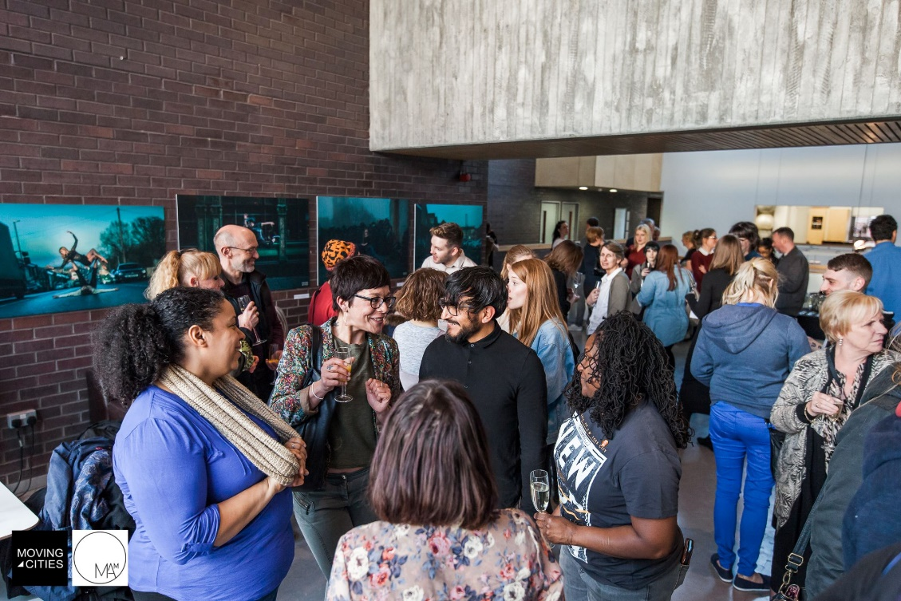
Photo by Anna Miller
In March 2020, Dance City is proud to host our first SOUP event, a networking opportunity which brings together an eclectic mix of local dance professionals to meet, have conversations around projects and pitch for investment for their new artistic and entrepreneurial ideas. Our SOUP event is an ideal opportunity to network with peer makers, North East venues and funders, as well as discover new ideas and initiatives from across the region.
A £2,000 pot of funding support is available, divided into four £500 bursaries. Three of these will be awarded through a democratic audience vote, and the fourth award will be decided by the panel.

As well as proposals for new performance work, we’re also keen to support site specific projects, work with a community focus, and personal and career development/upskilling ideas.
Each successful artist (max 10) will have a maximum of 3mins on the Dance City theatre stage to pitch their project idea to the panel and audience. You can choose how best to pitch your idea, verbally, with visual aids or by demonstration. We will need to know at least 7 days in advance if you require technical support. Four successful artists/companies will be awarded the cash bursaries, to be spent directly or used to leverage further support from other funding bodies towards their project/idea. Artists who are unsuccessful in receiving an award at SOUP will receive a £50 bursary for participating in the event. All artists pitching will receive complimentary soup and a drink during the networking session.

Our SOUP event hosts are Kiz Crosbie, Artistic Director and CEO of Mortal Fools and Dance City Board Member and Phil Douglas, Interim Director of Dance City and Director of Curious Arts. Phil Douglas and Chloe Stott, Dance City’s Ticket Office Manager and Associate Producer with Alphabetti Theatre and Grey Scale will be available on the 20th and 24th March for a Pitch Practice session to help you design and execute the perfect pitch. (30min meeting to be arranged with Interim Creative Producer Alex Anslow – alex.anslow@dancecity.co.uk) A follow up conversation with the Dance City Artistic Team at a mutually convenient time will be arranged with all bursary award winners to discuss what further support would be useful.

The panel of industry experts include:
- Alex Anslow – Interim Creative Producer at Dance City
- Katie Hickman – Programme Curator at BALTIC Gateshead
- Pippa Fox – Producer at Northern Stage
- Kristian Pellissier – Arts Council England Relationship Manager for Dance in the North
- Mandy Rogerson - BA (Hons) Dance Programme Leader at Newcastle College
- Dora Frankel – Independent Artist

To be eligible to apply you must be living or have trained in the North East and be making or managing a project which includes dance or physical movement (including circus). Only one application can be submitted per artist/company. On this occasion, Dance City Commissioned artists 2020-21 are not eligible to apply to ensure that we can support and fund a wider pool of artists across the region.
Dance City is particularly looking to support artists who identify as LGBTQ+, BAME/POC, Disabled and mature/50+.
We’ve outlined some aspects which we’d like the audience to consider before voting for their preferred project to receive an award. You may want to consider these points when designing your application and pitch.
- Strength or uniqueness of the artistic idea
- Potential for the project to be realised successfully and is it value for investment?
- The impact or contribution the project makes to the dance sector in the North East
- Does the work have a suitable and clearly identified target audience? (if appropriate)
Tickets for audience members will be available to the general public to purchase from Dance City’s Ticket Office from Tuesday 3rd March at 9am. Tickets are limited so early booking is encouraged. Tickets are £5 and include a bowl of soup and a drink during the event. Please advise at the time of booking if you have any dietary requirements.
Dance City is a fully accessible building with lift access, a hearing loop and accessible toilets. On request we can provide a BSL interpreter for both artists pitching or for anyone attending as an audience member. Please email us to discuss any access needs and we’ll do our best to accommodate.

We encourage artists pitching to think about how they can make the content of their pitch flexible and accessible. Ideas of formats to consider are images, video with subtitles, audio, handouts on white and cream paper, large print, captioning and audio description.
Our thanks to BALTIC Centre for Contemporary Art and Northern Stage for providing financial support towards the artist bursaries for our SOUP event, as well as their time and expertise in supporting the decision-making panel.
To apply:
We are happy to receive applications either as a written document below, by video, by voice note or phone call.
If you prefer to apply by phone, the date we are offering to arrange a call is Monday 17th February between 10am and 4pm. Please email alex.anslow@dancecity.co.uk to book your appointment. The number to call on the day is 0191 2610505, and our Ticket Office team will connect your call.
The content of all application formats should be using the same questions as below.
Please email video or voice note applications to Alex Anslow using WeTransfer.
If you would like to apply in writing, please complete and return by email the following information:
Dance City SOUP 2020 - Application Form
Name and/or Company name:

Where are you located?

Telephone and Mobile Number: | E-Mail Address:
Tell us about yourself as an artist/maker (250 words):

Tell us about your project or personal career/development idea (250 words):

If awarded a £500 bursary, what additional support would your project or personal/career development idea benefit from? (250 words)

Is there anything else you think we should know?

Deadline for submission of applications to Alex Anslow, Dance City’s Interim Creative Producer, alex.anslow@dancecity.co.uk is: 12 noon, Wednesday 19th February 2020.
Thank you.

