Dance City’s Residencies Without Borders 2020/2021

Dance City is seeking proposals from two dance artists/companies, one from the European Union and one from outside the UK/EU for their new Residencies without Borders. The residencies we are looking to support can be thematically diverse and the work you choose to apply with can be live performance, dance film or movement research. Dance City is a proud member of the European Dance House Network and the National Dance Network, and values and supports the global community of artists/companies we work with. We want to hear from artists/companies who share our mission to develop artistic exchange and cross-cultural dialogue.

Established for over 30 years Dance City is the North East’s leading development organisation for dance, which exists to lead and support a thriving dance ecology in the region. We present a regular programme of dance performances from contemporary to ballet, world to breakdance bringing leading North East, British and International dance to Newcastle. We also commission original new works, which premiere in our theatre. To find out more about Dance City please visit our website - https://www.dancecity.co.uk/about-us/

What you will receive:
- £750 bursary towards the cost of your residency (paid by BACS in pounds sterling upon receipt of an invoice, subject to the currency exchange rate at the time of payment)
- 1 week (5 days) of studio space at our Newcastle venue. (Dance City, Temple Street, Newcastle upon Tyne, NE1 4BR) The studio will be available from 9am – 5pm.
- 10% discount in our DC café for the duration of your stay
- A one to one meeting with Dance City’s Artistic Director and/or Creative Producer at a mutually convenient time during the residency week.
- Two, one week residencies (one per artist/company) can be selected from the dates available below:

Monday 13th July – Friday 17th July 2020 – Studio 4 Newcastle
Monday 14th December – Friday 18th December 2020 – Theatre Newcastle
Monday 4th January – Friday 8th January 2021 – Theatre Newcastle
Monday 19th July – Friday 23th July 2021 – Theatre Newcastle
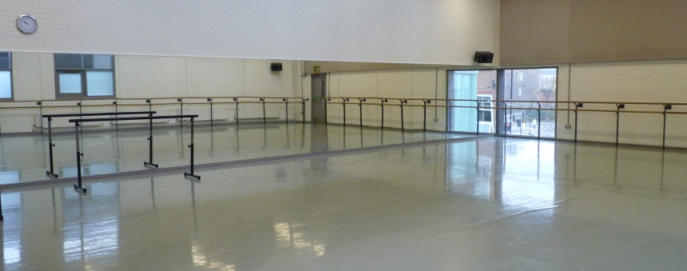

STUDIO 4, NEWCASTLE
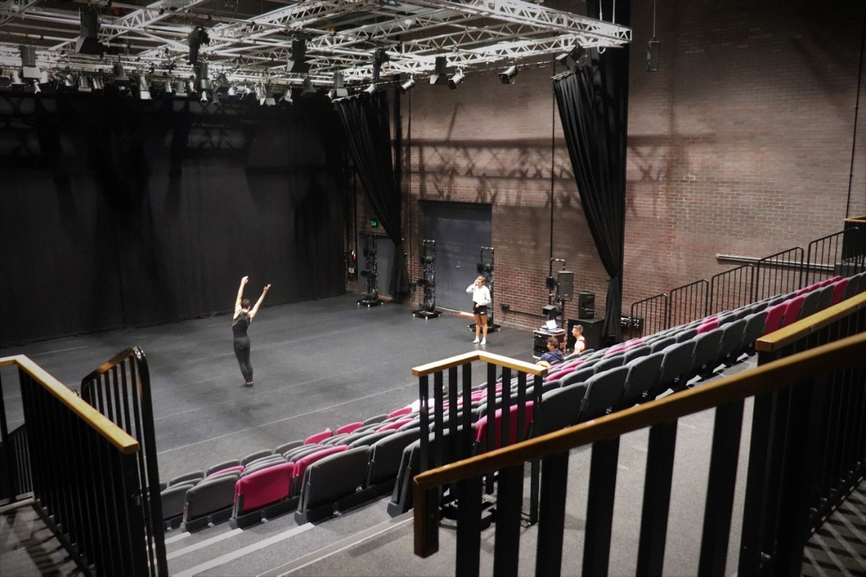
THEATRE, NEWCASTLE

What you must contribute:
- The chosen artist/company will lead a daily Professional Class each morning from 9.30am – 11am. Maximum class size – 20. The classes are open to local professionals and are free of charge to attend.
- Agree to meet for a team ‘huddle’ at 9am - 9.30am on the Monday morning, to meet the Dance City team and members of our networks. Tea and coffee will be provided.
- If appropriate, we can arrange to advertise a sharing of your work at the end of the residency week if you wish. This is optional and can be confirmed during the residency week if preferred.

Notes to consider:
- The work you are making should be a new idea, or a project you are currently researching and developing. Existing work which you are revisiting or redeveloping is not eligible.
- The chosen artist/company should arrive in the region the day before the residency begins to ensure maximum use of our facilities
- We encourage you to consider the environment when booking your travel arrangements.
- All visas, health insurance and travel insurance is to be arranged and paid for by the chosen artist/company. Dance City cannot provide advice or assistance on these matters.
- Our public dance classes take place each evening, therefore all equipment must be cleared from the studio at the end of each day. Please advise if you require overnight storage of any items.
- Dance City can offer a copy of our digs list which includes accommodation options for artists. The artist/company is responsible for arranging their own accommodation.
- No technical support is provided during the residency. You/your team are not permitted to use the in-house lighting and sound equipment without our supervision. This can be arranged at cost.
- Applicants must be currently residing in the EU or other international country, and not already in the UK.
- All replies within the application form and correspondence with Dance City must be made using the English language.

Timeline:

Call out announced | Friday 14th February 2020
Deadline | Friday 13th March 2020, 12noon
Shortlisting | Monday 16th March – Friday 20th March 2020
Artists confirmed by email including contract/agreement | Friday 27th March 2020
Contract, biography and image deadline | Monday 6th April 2020

Shortlisting Panel:

- Dance City’s Artistic Team

To apply:

Please complete and return by email the following information:

- The application form below
- Your CV (max 2 pages) Please include details of a referee who can vouch for your teaching expertise at a professional level (name, phone number & email)
- One image and one video (max 5mins) of your work. (This can be anything from your portfolio.) Media files must be sent using WeTransfer.

If you require this information in another format or would like to apply either by phone or in person, please email alex.anslow@dancecity.co.uk to discuss your request.

Successful artists will be notified by email by Friday 27th March 2020. Unsuccessful artists will be notified by Tuesday 31st March. Please note that we are unable to offer feedback on your application.

Residencies Without Borders 2020 - Application Form

Name and/or Company name:

Where are you located?

Telephone and/or Mobile Number: | E-Mail Address:
Tell us about yourself as an artist/maker and the work that you create (250 words):

Tell us about what you will be developing during the Residencies Without Borders week (250 words):

Please explain why a residency in Newcastle (UK) would benefit your practice and/or the work you are making? (200 words):

Are there any other activities you’d like to propose during your residency week? e.g talk, Q&A session, sharing, workshop etc. Please note there is no additional budget available to support these activities. (100 words):

How many artists will be attending the week: | Your preferred dates, please highlight a 1st and 2nd option:  w/c 13 July 2020  w/c 14 December 2020  w/c 4 January 2021  w/c 19 July 2021
Is your participation in Residencies Without Borders dependent on funding? If so when do you expect to have funding in place? If funding is not forthcoming, will you still be able to take part in Residencies Without Borders?

Is there anything else you think we should know?

Deadline for submission of applications to Alex Anslow, Dance City’s Interim Creative Producer, alex.anslow@dancecity.co.uk is: 12 noon, Friday 13th March 2020.

Thank you.

Agreement for Residencies Without Borders at Dance City

Agreement made this (date) 2020 between Dance North Ltd trading as
Dance City of Temple Street, Newcastle upon Tyne NE1 4BR, and XXX

Name
Company
Address
postcode
Telephone
E-Mail

Residencies Without Borders Remit

Residencies Without Borders exists to support dance artists from outside the UK to develop single or collaborative ideas involving choreography, dance and movement in Newcastle, UK.

Dance City’s responsibilities:

- To provide access to a Studio from 09.00 – 17.00 for the dates agreed

Your responsibilities:

- To adhere to the guidelines set out in the terms and conditions below
- To vacate the studio by 17.00 each day
- To include Dance City’s logo on any publicity should you perform any works connected to the research week
- To provide a free, daily, open Professional Class to artists from 9.30am – 11am in the studio during your residency to share your practice with local artists.

Date | Time in  Time out | Space booked

Space | unit | value | Total in kind
 | ? days | £? p/d | £?

Signed on behalf of Dance North Ltd trading as Dance City
Phil Douglas  Interim Artistic Director |  | Date

Signed on behalf of ?
Name  Position | Sign | Date

Dance City will not regard itself as having entered into a contractual relationship with you until such time as a full written contract is prepared, agreed and signed by both parties.

Contacts:
Phil Douglas phil.douglas@dancecity.co.uk 0191 269 5571
Alex Anslow alex.anslow@dancecity.co.uk 0191 269 5586

CONTRACT TERMS AND CONDITIONS
January 2020

General Terms:

  - The management and staff at Dance City will work with the Artist/Company to make your time at Dance City a success. However, Dance City cannot accept responsibility for the success or otherwise of your work.
  - Dance City staff has a policy of mutual respect as part of its working environment. We ask that you act in accordance with this, in relation to both the people and the building while you are resident here.
  - Eating and drinking is not permitted in the studios. You may only take bottled water in plastic bottles into the studios.
  - The Artist/Company shall leave the studios clean and tidy at the end of each day and/or at the end of the hire period.
  - Outdoor shoes are not permitted in the studios.
  - The Artist/Company shall sign and return a copy of this agreement to Dance City by return.
  - The Artist/Company shall be responsible for the safety and welfare of any company members during the hire period, the Artist/Company will adhere to Dance City’s health and safety policy and guidance, and respond to instructions from Dance City Staff regarding health and safety.
  - The Artist/Company will ensure that there is no driving or fixing of nails, screws or bolts into the floors or walls or other part of the studios, no alteration to the condition of the studio, no hanging of any items from any part of the internal finishes nor any alterations in any other fittings, seats, tables, or otherwise without the express written consent of the Technical Manager. Any alteration must be made good prior to the end of the hire period.
  - Dance City is a total no smoking environment both inside and outside the building. The Artist/Company shall be responsible for ensuring that this ban is strictly enforced.
  - You must be ready to leave the studio at the end of your allotted time

Marketing:

  - This provision of in kind studio space by Dance City does not constitute a partnership between you and Dance City.
  - Any publicity material for your project, produced by you or your company, including e-flyers, must acknowledge Dance City support in the form of the Dance City logo, available from Caroline Greener (0191 269 5583)

Safety and Legal Responsibilities:

  - Dance City cannot be held liable for any accident or injury sustained during your hire caused directly by your activity, or if applicable by members of your company
  - The Artist/Company must abide by all legal and license requirements, and those of Dance City.
  - For accounting purposes, visiting Artists/Companies must advise Dance City staff of their presence and numbers when onsite; and on arrival, must acquaint themselves with the evacuation procedures.

