A covid-safe Dance City: Professional Artists

As we start to open up the studios to artists this July we are letting groups with the maximum of 4 people use space, by law this amount of people working within one space, socially distancing/in an already formed bubble do not need to write a risk assessment. Come August we will be enabling larger groups of people to use studios but a risk assessment is needed for 5 or more people written by the lead artist/company, further detail about this is to be discussed with Alex Anslow.

Booking a studio
The Dance City building is now open to staff and professional artists who have booked in advance between the hours of 9am and 5pm Tuesday to Friday. Full and half day studio hire is available for groups of up to 4 so long as the individuals belong to the same household/bubble or they intend to maintain a social distance of 2 meters. Arrival and departure times will be allocated by Alex Anslow in order to prevent ‘traffic’ in the buildings entrance.

Before Arrival
If you display any of the listed coronavirus symptoms including a cough, a temperature or shortness of breath please do not enter the building. Please stay home and isolate for at least 14 days. Please inform a member of our team if you test positive for the virus after using the building.

Entering the Building
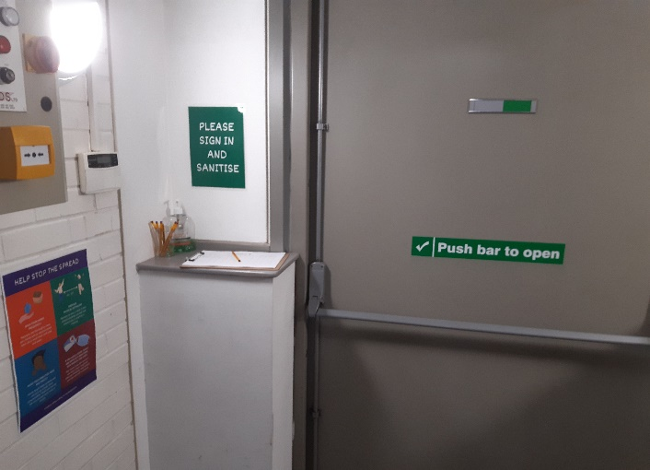
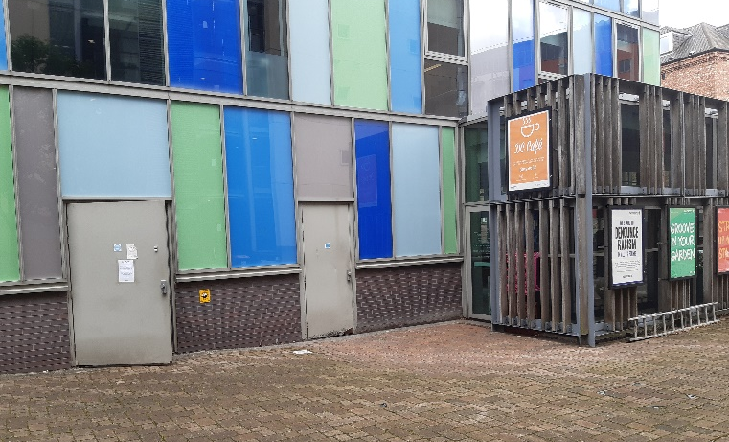
As Dance City remains closed to the public the front doors which are usually used for entry are not in use. To enter the building please use the grey door on the left side of the building (behind the DC Café and opposite the street level exit of the Grainger town car park. Please ring the doorbell (situated on the door) or call 0191 261 0505 to alert a member of staff to let you in. These instructions are also reiterated on the front and side entrances. Please step back two meters after ringing/calling so that the member of staff can open the door whilst maintaining a distance.

Upon arrival you will be asked to sign in and sanitise your hands before being given a briefing from a member of staff on our new social distancing procedures and how to safely move about the building.
We request people minimise the amount of times they come in and out if the building.

Moving about the building
In light of the ongoing coronavirus pandemic we ask that resident artists comply with the following procedures when using the building to help us limit the spread of infection and ensure a safe environment for all:
• Sanitise/wash your hands on arrival and departure from the building.
• Sign in and out using the sheet provided.
• Sanitise/wash your hands regularly using stations provided.
• Remain in your allocated studio as much as possible, and please do not enter DC Team workspaces/offices.
• Maintain a 2m distance from those around you.
• Regularly disinfect your work space using equipment provided.

Cleaning
The building is being cleaned professionally on Mondays and Thursday mornings.
Disinfecting wipes are available in each studio.
Hand sanitizer is available throughout the building.
If you require any additional cleaning equipment please let a Dance City team member know and they will be able to help you.
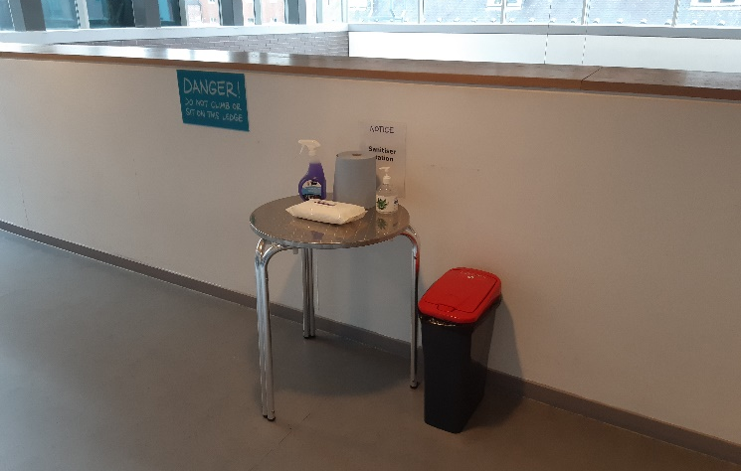
Water
Water fountains and showers are currently out of use. Tap water in the building is unfiltered so we ask that you bring your own bottles of water.

Risk Assessment
Dance City has conducted a full risk assessment of the building and have assessed that it is now safe for groups of up to 4 people who belong to the same ‘bubble’ to use studio space (if agreed in advance with a member of the artistic team). This risk assessment is being continually reviewed throughout the pandemic and further measures than those stated here may be added at any time in the pursuit of maintaining a covid-safe environment. Our full risk assessment of the Dance City building is available on request.

