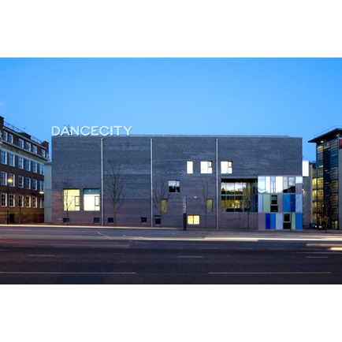

**Dance City Creative Winter 2020**

Creative Winter is our new residency programme, designed to support dance artists in developing single or collaborative ideas involving choreography, dance and movement. You are invited to develop ideas and work in one of our purpose-built studios in Newcastle upon Tyne. We are offering this space to artists, free of charge, in the run up to the festive season on the following dates:

|  |  |  |  |  |
| --- | --- | --- | --- | --- |
| **Dates** | **Venue** | **Times** | **Studios available** | **Studio Capacity Restrictions** |
| Monday 14 December – Friday 18 December  **(5 days)** | Newcastle | 9am – 5pm | 3 | 8 people max |
| Monday 14 December – Friday 18 December  **(5 days)** | Newcastle | 9am – 5pm  *(Friday 18th finish time is 1pm)* | 4 | 10 people max |
| Monday 14 December – & Tuesday 15 December  **(2 days)** | Newcastle | 9am – 5pm | Theatre | 10 people max |

*\*Please note: groups of over 5 people are required to carry out their own Risk Assessment. Groups of 4 people and under are not required to carry out a Risk Assessment.*

On the first day there will be a socially distanced ‘Welcome Huddle’ meeting for artists and staff to get to know each other. You are invited an encouraged to open up your morning class to professional artists. If you would like to host a sharing of your work at the end of your residency please discuss this with us. We will facilitate these where possible, but please note that attendance will be limited and social distancing measures will be in place, or alternatively these could take place online.

It is not possible for Dance City to offer any cash funding towards the Creative Winter residencies. However, we can offer our in-kind support for any funding applications that you may wish to submit, on request, in the form of a letter of support and details of the monetary value of the in-kind studio space and support that Dance City will offer you through this Creative Winter opportunity.

Government guidelines regarding travel, overnight stays and tier restrictions must be followed. You are responsible for booking your own travel and accommodation, and Dance City cannot support financially in any way if you are unable to travel, or if residencies are cancelled for reasons beyond our or your control.

Applications are to be made to Phil Douglas, Creative Producer at Dance City by completing the proposal form available on the website.

To apply to be part of Creative Winter 2020, please:

* Complete a proposal form and Equal Opportunities Monitoring Form
* Email your proposal to [phil.douglas@dancecity.co.uk](mailto:phil.douglas@dancecity.co.uk)

Please also familiarise yourself with our COVID measures so you are aware of what to expect when working at Dance City. Please read these carefully to ensure you are able to comply with our safety measures before making your application. Please note these are regularly updated and subject to change.

Proposals will be accepted from Friday 6 November and the deadline is 12 noon on Friday 20 November. Decisions will be taken by the programming team at Dance City and we will let people know by Friday 27th November.

If you would like to apply by video or via a telephone conversation, please email Phil Douglas to discuss in advance.

Kind regards,



Alex Anslow

Programme Coordinator

Telephone: 0191 269 5586 Email: [alex.anslow@dancecity.co.uk](mailto:alex.anslow@dancecity.co.uk)