Dance City Creative Winter 2020
EASY READ
Dance City
Dance City is a place where people, both amateur and professionals, go to socialise, learn new skills, keep fit and active, train professionally and find out more about dance. Established for over 30 years Dance City is the North East’s leading development organisation for dance.

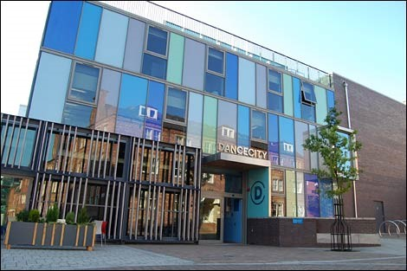

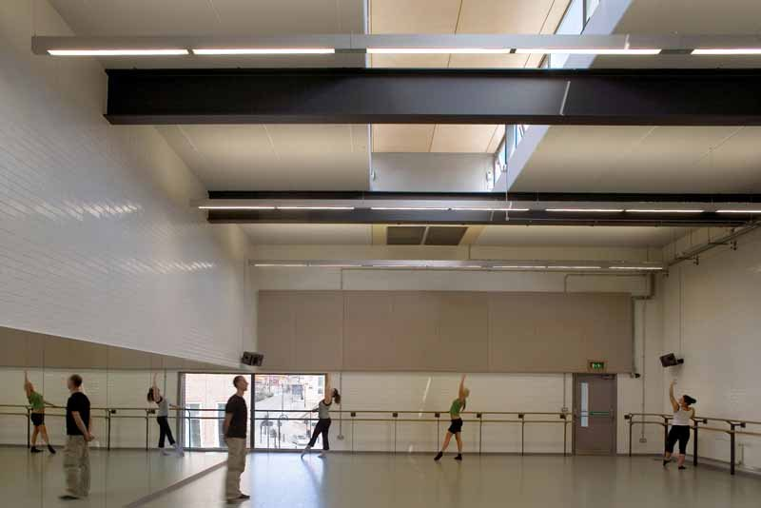
Creative Winter
This is the name of our new residency programme. We are giving studio space to dance artists to use for free to make new dance work.

You have to be a professional dancer to apply, and you can practice, make, rehearse or train in any dance or movement style you like. You can use the studio space on your own, or with other dancers and collaborators.
This table tells you what space is available, on which days and at what time. You must select which one you prefer and tell us as part of the application process.

Dates | Venue | Times | Studios available | Studio Capacity Restrictions
Monday 14 December – Friday 18 December  (5 days) | Newcastle | 9am – 5pm | 3 | 8 people max
Monday 14 December – Friday 18 December  (5 days) | Newcastle | 9am – 5pm  (Friday 18th finish time is 1pm) | 4 | 10 people max
Monday 14 December – & Tuesday 15 December  (2 days) | Newcastle | 9am – 5pm | Theatre | 10 people max

We will discuss with you and help you to write a Risk Assessment document if your group has more than 5 people in it. This is important because we need to make sure the risk of spreading Coronavirus is as low as possible and everyone stays safe. Groups of 4 people or less don’t need to do this.

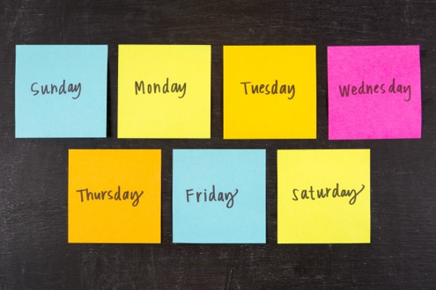
On the first day you will meet some staff from Dance City to say hello and introduce yourself as part of our Welcome Huddle meeting. On the last day, if you want, you can share what you have been making with a small group of invited guests or digitally. You can also teach a morning class to professional artists if you want.

All of these activities will be socially distanced.

Dance City cannot give you any money towards the Creative Winter residency. We are giving the studio space to artists for free, so if you need us to give you a letter as evidence so you can show it to other funders or supporters then we can do this for you. We also can’t cover costs for travel or accommodation, and we can’t pay for costs for any cancellations. You have to make these bookings yourself, however we can offer some recommendations for places to stay if you need help.

If you’d like to apply, please send an email to Phil Douglas at Dance City including:

- Your completed Proposal form
- An Equal Opportunities Monitoring Form

phil.douglas@dancecity.co.uk

You need to download the forms from the website.

Please also read our COVID safety measures before you apply too, so you know what processes are in place when you visit us. These are updated regularly so might change, and we will send you an updated version if needed.

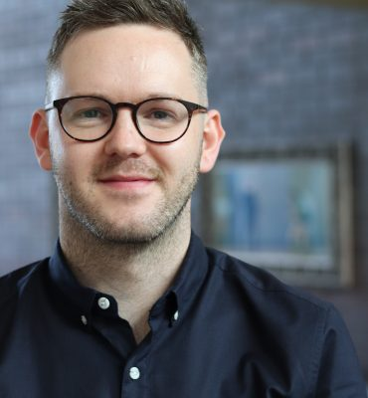
This is Phil Douglas, he is the Creative Producer at Dance City.

The deadline to send your Proposal form to Phil is Friday 20 November 2020 at 12noon.

Phil will let you know if your application has been successful by email by Friday 27 November.

If you would prefer to apply by video or by telephone instead, please email Phil to discuss this. If you have any questions please ask Phil by email or calling her at work between Monday and Friday, 9am – 5pm on 0191 2610505.

Thank you

