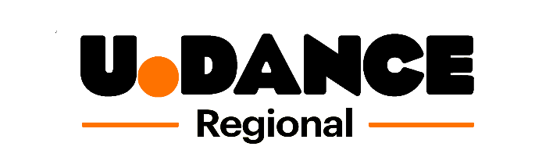

U.Dance 2021 North East Regional Platform
Application Form
Please answer all of the questions below and include with your video submission. Full details on how to submit can be found below.
Name of group
Name of group leader
Email address
Main contact number
Postcode where group meets
Do any members of your group identify as having a disability?
Please outline your group’s Covid-19 working practices:

Equal Opportunities Monitoring
Please include an ‘X’ or a number next to your chosen answer.
Gender
Male Female Prefer not to say

Type of Group

School Youth Dance Company Private Dance School Other

Group ages
Up to 16 16 - 18 19+

Submitting your application
Please follow the guidelines below to enter your submission.

Submission Checklist:
So that we can consider your submission please ensure that you submit the following:
1. A completed application form on behalf of your group
2. Your full length video as an MP4 or MOV file

Naming your files:
This is very important. When uploading your files please rename ALL your files clearly with the name of your group, the title, and the date of submission.
For example :
DANCE CITY, U.DANCE APPLICATION FORM, 02.12.2020
DANCE CITY, DANCING IN THE MOONLIGHT, 02.12.2020

Submitting your files:
OPTION 1 (Preferred)
Please upload your files onto Dropbox by clicking on the link below:
https://www.dropbox.com/request/JYoqgkcfmKtNXp3ggetc

OPTION 2

If you are having difficulties with option 1, then please use http://www.wetransfer.com to send your files. Please send them to helen.kumar@dancecity.co.uk

