**Dance City *EASY READ***

**Outdoor Commissions 2021**

**Dance City**

Dance City is a place where people, both the public and professionals, go to socialise, learn new skills, keep fit and active, train professionally and find out more about dance. Established for over 30 years Dance City is the North East’s leading development organisation for dance.

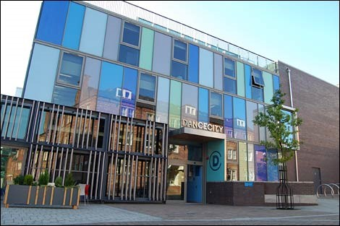

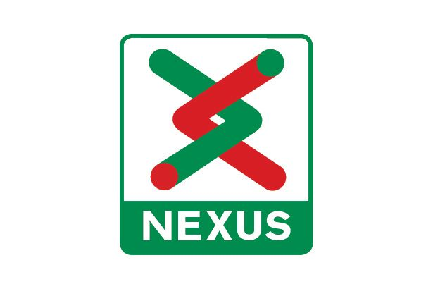

Nexus is the public body which owns and runs the Tyne and Wear metro, as part of its role to provide local transport in the region. It supports a longstanding programme of public arts partnerships and commissions.

**The opportunity**

Dance City would like to commission (to offer money, studio space and resources) a professional dance artist (makers/ choreographers), to create outdoor dance work. The project budget for this commission is £6000.



The work created must be for an outdoor performance. The work will be performed in and around station sites, as well as on platform areas.

You will be working with Dance City’s MA students to create this work.

The work can be of any dance style.

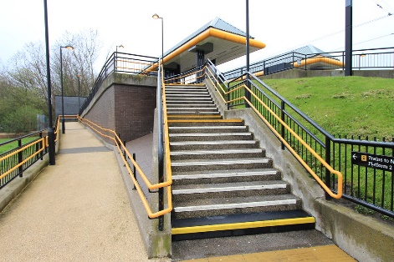

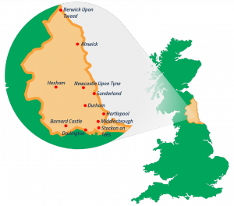

To apply, the company/ artist must:

* Be based, from, trained or living in the North East.
* Be makers of dance or physical theatre work of any genre.
* Have experience in making outdoor work.
* Have experience of applying to other funders to attract additional resources to realise this work.
* The work must be new or at early stage of Research and Development.

Everyone is welcome to apply.

We are also looking to support artists who identify as:

* LGBTQ+ (lesbian, gay, bisexual, trans,

queer +)

* Black, Asian, ethnically diverse

* Neurodiverse/Disabled

* Mature/50+.





To apply for a commission you need to complete the Expression of Interest application form. If you prefer to have a face to face meeting, or apply verbally by phone, or by sending us a video, please email Alex Anslow to discuss this first: [alex.anslow@dancecity.co.uk](mailto:alex.anslow@dancecity.co.uk)

The application process is in two stages:

1. Stage 1 - Expression of Interest (Written/ Video Application)

2. Stage 2 – Interviews (via Zoom)



Overall Guidelines:

* The themes of the commission are heritage and community. The essence of reconnecting our communities after the pandemic should be reflected within the artistic themes.
* The commissioned artists will be required to work alongside the Dance City MA students, and be prepared to be in conversation with the BA & MA Programme Leader Gillie Kleiman and Associate Artist of the MA Programme David Lloyd.
* We expect the work to be a minimum of 10 minutes long.
* Please consider accessibility regarding the work. All spaces for performances must have good sightlines and be accessible to everyone.
* The metro stations will be used subject to risk assessment. You must be flexible in your approach as this is a live transport network.

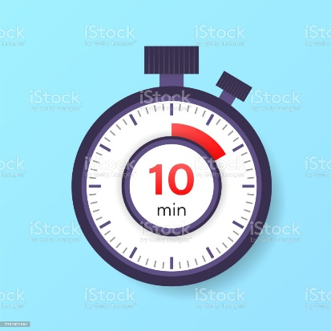

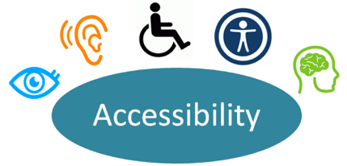

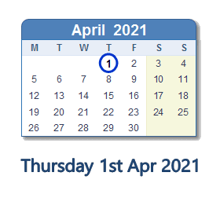

**The deadline for the Expression of Interest is:**

**Thursday 1 April at 12 noon.**

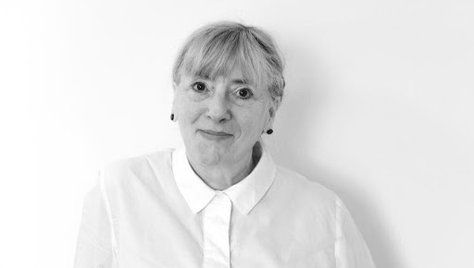

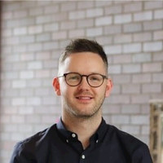

A panel of experts will decide which artists they would like to award the Commission to.

The Commision panel is:

* Stella Hall
* Phil Douglas
* Gillie Kleiman
* Lynn Dickinson
* 2 MA students (TBC)

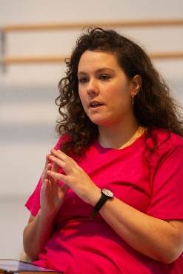

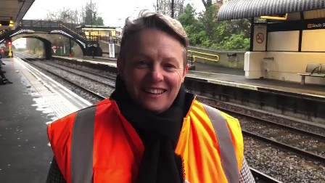



If you have any questions, please email or phone Alex Anslow (Executive Assistant, Creative Producer and Programme Coordinator):

[Alex.anslow@dancecity.co.uk](mailto:Alex.anslow@dancecity.co.uk)

0191 269 5586

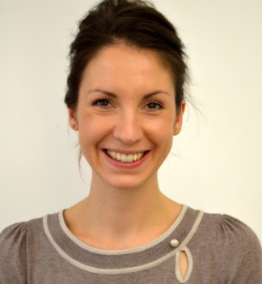



**Dance City MA and Nexus Commission is as follows:**

This commission is for development of new/ early stage work - a live outdoor dance work (over 10 minutes long). Artists will be granted £6,000.

Each company/ artist will receive:

* X1 day technical support, plus complimentary hire of a sound system to be used on performance dates.
* Marketing support via Dance City, Nexus and project partners networks.
* X 3 weeks of studio space at Dance City Sunderland, Mon- Fri 9am-5pm.
* Creative support from Gillie Kleiman (BA & MA Programme) and David Lloyd (Associate Artist, MA Programme)

Each company/ artist agrees to:

* Artists will be required to deliver professional level technique training each day prior to rehearsals.
* The artist should be prepared to work for the hours suggested; it will not be possible to extend or shorten rehearsal times.
* The artist is required to keep a journal in the development of their practice. Aspects of this content are to be shared publicly.
* You are expected to attend meetings and site visits ahead of the creation weeks.
* You are expected to deliver a minimum of 1 workshop with a local community group to share creation process of the new work.
* You must have your own Public Liability Insurance.
* You will need to submit your own risk assessment for your work.
* The commissioned artist/s will need to adhere to all COVID safety restrictions.
* All permissions and licences used for music used must be obtained.

**Key Dates**

**Commission Rehearsal Dates:**

Monday 19th July- Friday 23rd July, 9:30-5pm- Dance City studios

Monday 26th July- Friday 30th July, 9:30- 5pm- Dance City Sunderland studios

Monday 2nd August- Wednesday 5th August, 9:30- 5pm Dance City Sunderland studios

**Commission Performance Dates:**

Thursday 5th August 2021

Friday 6th August 2021

Saturday 7th August 2021

**Expression of Interest**

1. **Please tell us about your recent artistic work, experience and achievements. (250 words)**

(Artistic interests, style and inspiration for your work. What have you previously made?)

1. **What experience do you have making outdoor or site-specific work? (250 words)**
2. **What is your artistic concept for the Commission? (300 words)**

(Please describe the idea for your artistic work)

1. **What is your commitment/ connection to the North East? (150 words)**

(Do you live, or did you train here? How will you contribute to the development of the dance sector?)

1. **Please outline how you might engage the public in making this work. Does the work have opportunities for engagement? If yes, please tell us more. (250 words)**
2. **Please provide any links to your work.**

*Videos (max 2), images (max 10), reviews (max 2), testimonials (max 2), audience feedback (max 2), websites (max 1).*

1. **Which other trusts/ foundations/ funders are you approaching to financially support the creation of this work? (150 words)**

(We encourage you to use the commission money to leverage further support for your work from other sources)

1. **Do you have any producing or mentoring support for this project? (250 words)**

If so, please include their details below. If not, please outline who you would like to work with, or if your project is self- produced please tell us your experience and expectations for this project)

1. **Please attach a budget overview, in excel format. This should include the full costs of the project, including the commission funds. (max 1 page)**
2. **Please briefly summarise the support Dance City has offered you/ your company during your career, if any. (max 250 words)**

(e.g commission, performance date, studio space, staff time, equipment loan, office space etc.)

1. **Please detail your current or prospective creative team (e.g dramaturg, costume designer, producer etc) (max 150 words)**



If you have access requirements or need support, please email or phone Alex Anslow (Executive Assistant, Creative Producer and Programme Coordinator):

[Alex.anslow@dancecity.co.uk](mailto:Alex.anslow@dancecity.co.uk)

We are happy to offer a 15 minute informal conversation with one of our Artistic team prior to submitting your application.



Please email the completed form/ video to Alex with **Dance City Metro Takeover Commission 2021** as the subject line, by 12 noon, Thursday 1st April.

Applications submitted after this date will not be considered.