MAKE YOUR MOVE
16/09/2021
Share:
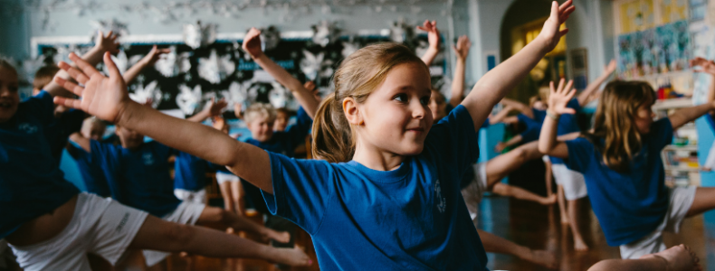
‘MAKE YOUR MOVE’ DANCE PACKAGE FOR SCHOOLS AND COMMUNITY GROUPS
This fantastic package, delivered by our highly skilled, qualified dance artists, is tailored to the specific needs of your school or community group. ‘Make your Move’ brings dance to you step by step and is guaranteed to get your young people:
Moving, having fun, learning new styles of dance, exploring themes, understanding how to build choreography, seeing professional works, performing on the big stage and achieving Arts Award.
A fantastic dance package allowing young people to SEE, SHARE AND CELEBRATE DANCE.
WHATS INCLUDED?
- X12 1-hour sessions with a DC Artist (working with Max 30 children)
- Creating a piece of dance week by week.
- Arts Award linked to all lessons.
- Perform final choreography
- 1 Hours FREE CAT workshop for years 5 or 6.
Each term has a different focus, depending on the term you sign up for your young people will get to SHARE, SEE AND CELEBRATE their dance achievements.
You decide how many terms you want to work with us for 1, 2 or all 3! Each term offers a different enriching dance experience for your young people.
TERM 1 – SEPTEMBER – DECEMBER 2021
SHARE!
After the 12 sessions young people will be given the opportunity to share their work within their community.
The great thing about working with Dance City is that we have lots of great partners and relationships with arts and community settings across the region so we can tailor this experience to what would be best for your school.
The sharing could be at a community venue, a local arts venue or on film. Giving your young people a taste of what it is like to perform in different settings.
TERM 2 – JANUARY – APRIL 2022
SEE!
After the 12 sessions not only will your young people be given the chance to perform their work at school, but they will be able to see a professional works which will be either showcased in Newcastle’s Dance City in house theatre or at one of our partnering Arts Venues.
A chance to see professional dancers, observe their performance and develop even more leaning about choreography.
TERM 3 – APRIL – JULY 2022
CELEBRATE!
After the 12 sessions young people will be given the chance to perform their work as part of a dance festival including other schools and community groups in our Dance City theatre. A great opportunity to perform on the big stage and witness other dances performed by young people from across the region. Celebrating success and achievement together.
COSTS:
£1200 per term
Discounts for Schools Trusts and multiple school bookings.
Get in touch today to book ‘Make your Move’ contact our schools lead Cheryl Baty, cbaty@dancecity.co.uk.
Visit our website for further information www.dancecity.co.uk.

Testimonials
‘It was my first experience of Dance City. As head, I know that dance lessons had been going on...I had seen bits and bobs. However, I was absolutely gobsmacked when I saw not only my school but the overall performance. The quality and messages were superb. I’m sure we’ll be working with you again.’
‘Excellent – very skilful delivery of the dance workshops pitched at the children’s level and led with a great deal of energy, humour and understanding of how to move the children on.’
‘The team were brilliant with the planning and communication regarding the event I knew exactly where we had to be, at what time, doing what activity and how much it would cost.’

