DANCE CITY COMMISSIONS 2022-2023
EASY READ OVERVIEW
Dance City is a place where people come to socialise, learn new skills, keep fit and active, train professionally and find out more about dance.

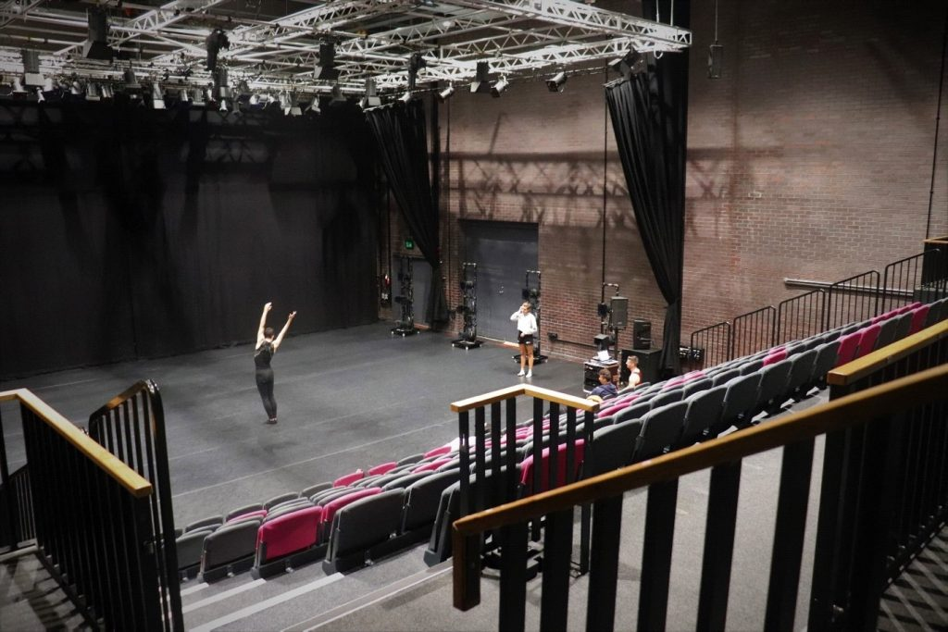
We have a Theatre space which has 240 seats
We have four dressing rooms.
We have a full lighting rig and sound system and we can also screen films.

Dance City would like to commission (to offer money, studio space and resources) professional dance artists to create new dance work for the 2022-2023 season.
The total Dance City Commission 2022-2023 budget is up to £40,000.

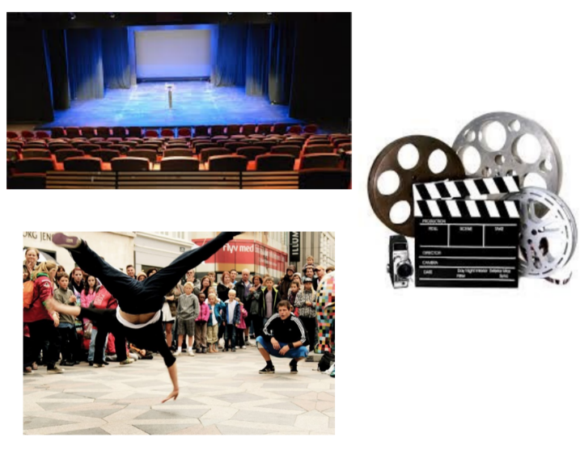
Your dance work can be made for a stage, a dance film, or for outdoors.

By dance we mean all movement focused work, including aerial and circus arts.

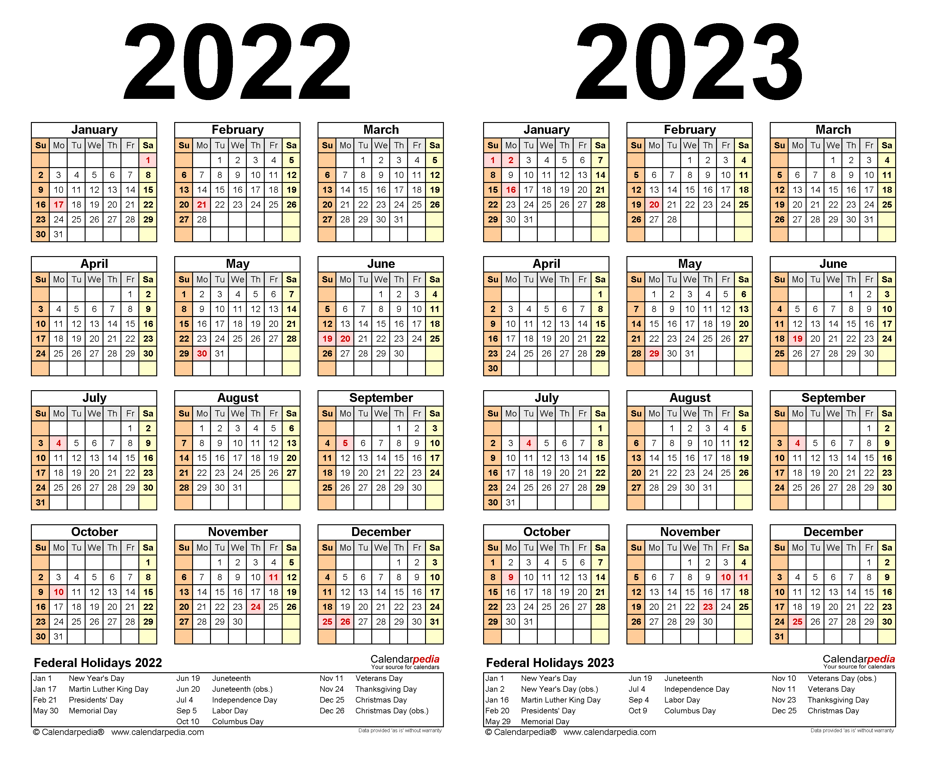

The start date for the commission period is 1 April 2022.

Commission funds will be released in instalments from April 2022, to be discussed and confirmed with Dance City.



There are 3 commission strands available:

- Full Production (up to £12,000)
- Early-Stage Work (up to £6,000)
- Charlotte Grant Early Career Award (£2,500)

Please read the details for each strand carefully to choose which is the best one for you. Details can be found at the end of this document.

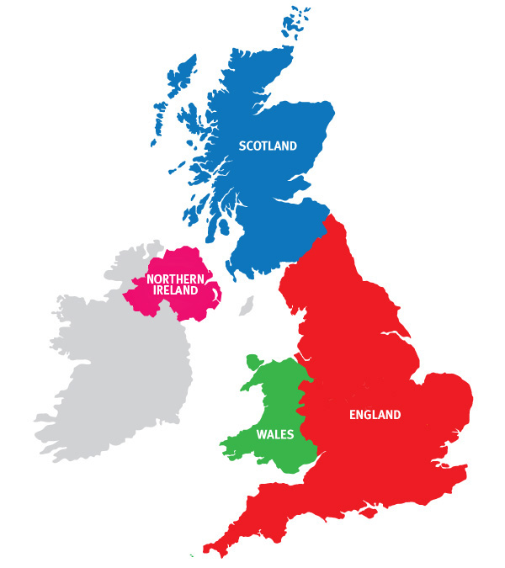

Applications for the Full Production and Early-Stage Work Commissions are welcome from across the UK.

The Charlotte Grant Early Career Award Commissions are for artists who are from, who studied at undergraduate level or above, or who are based in the North and North East of England.



Please only apply for one work per company, per commission round.

You can apply even if you’ve applied before.

You can apply even if you have had a commission from Dance City before.


We would like to offer a financial contribution to the time you have spent applying for the commission:
Stage 1 – No financial contribution.
Stage 2 - £50 contribution for artists not invited to interview.
Stage 3 - £50 contribution for artists who were not awarded a commission at the interview stage.
(The above amounts are including VAT, and paid by BACS upon receipt of an invoice.)

Everyone is welcome to apply. We are also looking to support artists who identify as:
- LGBTQIA+ (lesbian, gay, bisexual, trans, queer, intersex, asexual +)
- Black, Asian, Ethnically Diverse
- Neurodiverse
- Disabled


To apply for a commission you need to complete the Expression of Interest application form.
If you prefer to have a face to face meeting, or apply verbally by phone, or by sending us a video, please email Alex Anslow to discuss this first (alex.anslow@dancecity.co.uk)


The application process is in three stages:

- Stage 1 - Expression of Interest
- Stage 2 - Full Application
- Stage 3 – Interviews


Things to consider:
Think carefully how your work can be adapted in the event of an increase in COVID restrictions.
Government guidelines and Dance City’s COVID safety measures are to be understood and followed.


Guidelines

Please tell us about your producer support, mentoring support, and evidence of how your work will contribute to the dance sector.



Outline other sources of funding you are exploring to support this application.



The work can be tailored towards small, medium or large scale across each of the 3 strands.

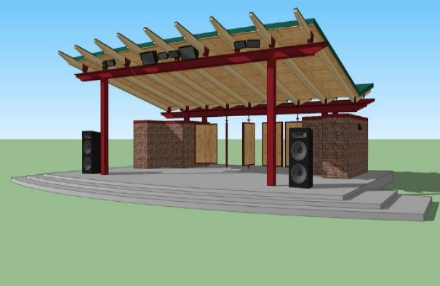
Costs and management of outdoor work is the responsibility of the artist.
Evidence of Licenses, Permits and Risk Assessments for outdoor work must be available if asked for. Dance City can offer support with this.
Artists applying for film work must build in technical costs into their budget. Dance City can offer to support with in-house equipment, additional hires must be covered by the artist.

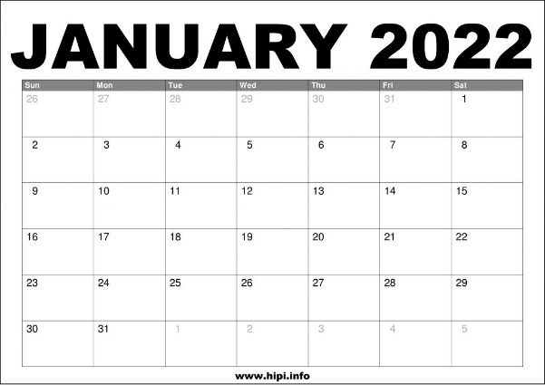

Applications are to be received by Thursday 6 January 2022 at 12noon



If you have any questions email or phone Dance City’s Producer Alex Anslow:
Alex.anslow@dancecity.co.uk
0191 269 5586



Dance City Commissions are as follows:

Full Production
This opportunity is for artists/companies who are producing a full-length live performance, film or outdoor dance work (minimum of 50 minutes in length).

Up to 2 artists/companies will be awarded up to £12,000 each. Up to one of the Full Production commissions could be awarded to an artist/company who is from, live and/or have trained at undergraduate level or above in the North East of England.

Please note, only up to one grant could be awarded for a full-length film or outdoor dance application.

Each artist/company will receive:
- A date in Dance City’s Professional Performance Programme between January 2023 – March 2024 if appropriate. Alternative platforms or outdoor locations can be discussed with Dance City’s Artistic Team.

The following In-Kind support:

- Fifteen days of in-kind studio space in either our Newcastle or Sunderland studios (depending on availability). In-kind value up to £3,000 per week.

- Marketing advice, support and consultancy specific to this work (for example, could consist of, social media support and promotion opportunities, and up to eight hours of Marketing and Audience Development advice). In-kind value up to £1,000.

- Up to 10 hours of producing support specific to this work. In-kind value up to £500.

- Up to one meeting with the Technical Manager, one full production day in the Theatre in Newcastle in advance of the performance and one performance day in the theatre. In-kind value up to £2,350.

- Up to eight hours of free access to our meeting room facilities in Newcastle. In-kind value up to £200.

- Potential opportunity to have your commission piece and experience digitally documented online. In-kind value up to £500.

Total in-kind value for full commissions: up to £9,550

The commissioned artist/company agrees to:
- Offer a minimum of two 1.5hr professional classes (or equivalent 3hr workshop/talk) at our Newcastle venue as part of our morning Pro Class offer to local professional dance artists.

- Offer a minimum of one opportunity for local professional artists/companies to access open rehearsals/talks/workshops/informal sharing’s.

- Offer a minimum of one opportunity for audiences to experience their work/rehearsal/process.

- Attend meetings with the Dance City team to discuss the development the progress of the work and to evaluate.

- Deliver an engagement activity or post-show discussion with the audience after the performance.

- Take part in Dance City’s documentation and promotion of the Dance City commission’s programme.

- Supply images and copy when requested and in response to deadlines

Early Stage Production

This commission is for development of early stage work - a live dance performance, film or outdoor dance work (15 – 30 minutes in duration).

Up to 2 artists/companies will be offered up to £6,000 each. Up to one of the Early Stage commissions could be awarded to an artist/company who is from, live and/or have trained at undergraduate level or above in the North East of England. The other will be awarded to an artist/company who is from, live and/or have trained at undergraduate level or above in the North of England (including the North East).

Please note, only up to one of these grants could be awarded for an Early Stage Production film or outdoor dance application.

Each artist/company will receive:

- A performance opportunity in Dance Edits programme (Autumn 2022, date TBC) if appropriate for the work produced. Other platform opportunities can be discussed with Dance City Artistic Team.

The following In-Kind support:

- 10 days of in-kind studio space in either our Newcastle or Sunderland studios (depending on availability). In-kind value up to £2,000.

- Up to three hours of marketing support specific to this work (for example, could consist of, social media support, self-marketing pack, audience advice and support promotional opportunities via Dance City marketing channels). In-kind value up to £400.

- Up to three hours of producing support specific to this work. In-kind value up to £150.

- Up to three hours of technical support specific to this work. In-kind value up to £185.

- Up to 4 hours of free access to our meeting room facilities in Newcastle. In-kind value up to £120.

- Potential opportunity to have your commission piece and experience digitally documented online. In-kind value up to £500.
Total in-kind value for Early Stage commission: up to £4,355
The commissioned artist/company agrees to:

- Offer a minimum of 1.5 hour professional class at our Newcastle venue as part of our morning Pro Class offer to local dance artists.

- Offer a minimum of 1 opportunity for local professional artists/companies to access open rehearsals/talks/workshops/informal sharing’s

- Offer a minimum of 1 opportunity for audiences to experience their work/rehearsal/process

- Attend meetings with the Dance City team to discuss the development the progress of the work and to evaluate.

- Take part in Dance City’s documentation and promotion of the Dance City commission’s programme.

- Supply images and copy when requested and in response to deadlines.

Charlotte Grant Early Career Artist Award
This commission strand is kindly supported by the Charlotte Grant legacy donation gifted by her family, and supported and match funded by Arts Council England. This commission strand is created in memory of Charlotte who trained and developed her professional career here at Dance City, and generously pays forward this opportunity for more artists to follow in her footsteps.

This commission is to support BA or MA graduates who have graduated in the last three years and who are from, live and/or who have trained at undergraduate level or above in the North East of England.

Up to 2 artists will receive a commission of £2,500 each, to develop early stage work - a live dance performance, film or outdoor work (5 – 15 minutes in duration).

There is the opportunity for the commissioned work to be showcased in Dance City’s theatre if appropriate.

As part of this specific commission strand Dance City is offering the option to support up to two artists with a one week residency outside of the North East. If a residency is realised as part of a commission we encourage the artist to ringfence up to £500 of the award to fund it.

Each graduate will receive:

- A performance opportunity in Dance Edits programme Autumn 2022 or an alternative equivalent if appropriate for the work produced. Other platform opportunities can be discussed with Dance City programming staff.

The following In-Kind support:

- Five days of in-kind studio space in either our Newcastle or Sunderland studios (depending on availability). In-kind value up to £1,000.

- Up to three hours of marketing support specific to this work (for example, could consist of, social media support, self-marketing pack, audience advice and support promotional opportunities via Dance City marketing channels). In-kind value up to £400.

- Up to three hours of producing support specific to this work. In-kind value up to £150

- Up to three hours of technical support specific to this work. In-kind value up to £185.

- Up to four hours of free access to our meeting room facilities in Newcastle. In-kind value up to £120.

- Potential opportunity to have your commission piece and experience digitally documented online. In-kind value up to £500.

Total in-kind value of Charlotte Grant commission: £2,355
The commissioned artist/company agrees to:

- Offer a minimum of one opportunity for local professional artists/companies to access open rehearsals/talks/workshops/informal sharing’s

- Offer a minimum of one opportunity for audiences to experience their work/rehearsal/process

- Attend meetings with the Dance City team to evaluate progress

- Take part in Dance City’s documentation and promotion of the Dance City commission’s programme.

Supply images and copy when requested and in response to deadlines.

