**Dance City *EASY READ***

**Board Recruitment**

**What is Dance City?**

Dance City is a charity and its main objective is that of promoting, maintaining, improving and educating by the encouragement of the arts. We primarily focus on dance, but touch on drama and music and many other artforms too.

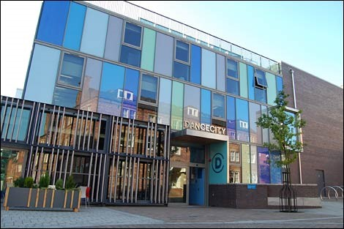



**The opportunity**

The Board of Dance City is looking to appoint new Board Members to provide inspirational leadership and strategic vision to take the charitable organisation onto its next stage of development.

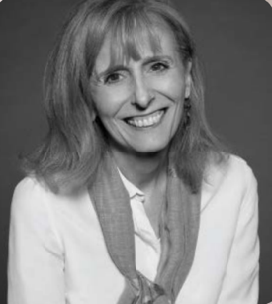

New Board Members will help us to ensure a sustainable business model that successfully serves our audiences, communities and stakeholders for decades to come.

**The current Board team members**

Sharon Paterson is the Chair of the Board of Dance City

Anand Bhatt is the Artistic Director and CEO of Dance City.

You can read about all of the current board members here – www.dancecity.co.uk/about-us/people

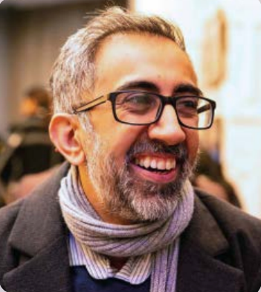

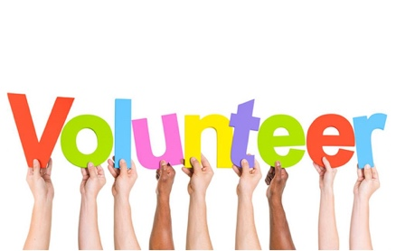

**Salary and Expenses**

This is a voluntary role, so no salary is offered to any Board Members.

Dance City will cover reasonable travel costs from outside the north east. We will also cover costs for access requirements needed for you to carry out your role as a Board Member.

The Board aims to meet in person, but when this is not possible the meetings will take place online via Zoom.

Dance City is committed to working inclusively and we try our best to meet people’s access needs to enable them to attend meetings and engage fully; this includes using accessible spaces and covering access support costs.

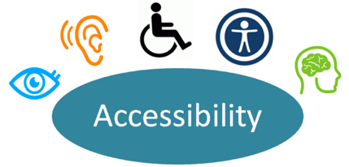

You will need to attend the following meetings and events:

* a minimum of 4 Board meetings per year (usually late afternoon in Newcastle or on Zoom).
* Annual Board Away Day
* Occasional individual meetings with the Executive team or Chair.
* Sub-committee meetings as required (at least quarterly).*
* Attendance at least two Dance City events per year.

The overall time commitment is estimated at 1-2 days per quarter.







**Length of Service**

3-years with a review with the Chair after six months and the potential to be reappointed for an additional 3-year term.

**Your responsibilities as a Board Member**

* Make sure Dance City as a charity is carrying out its purposes in relation to public benefit
* Approve artistic and creative plans, ensuring these are realistic and achievable
* Comply with the charity’s governing document and the law
* Fully understand the legal duties and responsibilities of Board Members and be committed to good governance
* Manage the charity’s resources responsibly, setting strategy in accordance with the governing document, legal and regulatory guidelines, and the Company’s business plan, and monitor outcomes
* Provide support, advice, expertise and constructive challenge to the Senior Leadership Team (SLT)
* Ensure the charity is accountable, operates in accordance with company law and is compliant with Charity Commission requirements

.







* Monitor the financial viability of the charity, ensuring prudent financial management and that the company’s assets are safeguarded and well managed, overseeing budgets, management accounts and annual financial statements
* Actively support the charity in achieving its fundraising targets
* Define the charity’s employment policies
* Make decisions relating to hiring of Directors
* Agree job descriptions for Senior Leadership Team and regularly review levels of pay
* Review and authorise all Dance City policies
* Act at all times in the charity’s best interests and with reasonable care and skill





We’re looking for someone who is…

* knowledgeable and experienced in their area of specialism
* enthusiastic about the art form with a strong commitment to the charity’s values and approach
* a clear communicator, able to articulate position, beliefs and rationale in an inclusive way
* able to operate with integrity and respect confidentiality when required
* well respected in their field of work with contacts that can be of assistance to the charity
* a strategic thinker, able to navigate and understand multiple stakeholder relationships
* understanding and accepting of the legal duties required
* able to commit the time needed for the position

Board Members are expected to hold all matters related to the business dealings of Dance City in strict confidence.

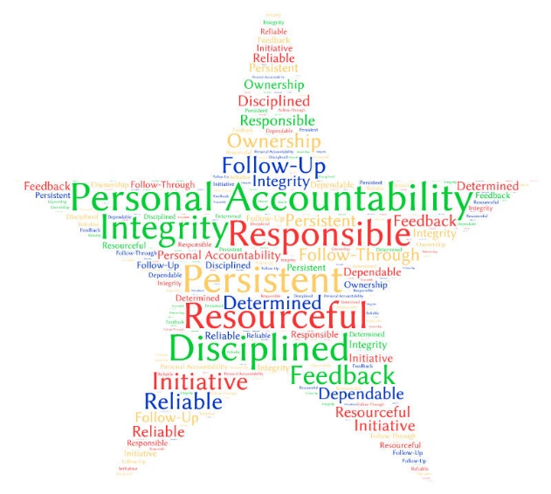



**Your skills**

We are looking for new Board Members with knowledge and expertise in a range of areas. You will not be expected to take on sole responsibility for these areas as the Board is collectively responsible for its actions and decisions.

We hope Board Members will contribute to a range of matters drawing on their individual interests and skills. We actively encourage applications from those who self-identify as black, Asian, ethnically diverse, lesbian, gay, bisexual, transgender, queer, neurodiverse and disabled.

We also welcome applications from people under 30 years of age.





**How to Apply**



Please send us your CV and a covering letter including:

* A description of what you feel you can contribute
* The area of specialism you can bring to the Board and examples of how you meet the requirements of the role
* Please also include details of any business or other interests which might give rise to conflicts of interest, and how you would address this should your application be successful, plus any other information, including other board or advisory roles, that you think will help the panel.



Your application can be in written, video or sound recording format.

**Deadline**

There is a deadline for applications of 31 August 2022. However please send an application beyond that date as we are recruiting Board Members on an ongoing basis throughout 2022.



Please email your application to: [Philippa.mcardle@dancecity.co.uk](mailto:Philippa.mcardle@dancecity.co.uk) with ‘Board Member Application’ in the subject box.

Please complete the equal opportunities monitoring form. The information will help us monitor the fairness and effectiveness of our selection processes and identify barriers to selection. Your answers will be kept strictly confidential and used for statistical monitoring purposes only; they will not be seen by the individuals making the appointment.



Dance City is a National Portfolio Organisation (NPO), receiving core funding from Arts Council England.

When making an application, please read the Arts Council’s Relationship Framework (www.artscouncil. org.uk/sites/default/files/download-file/ ACE_RelationshipFramework.pdf).

If you are inducted to the Dance City Board you will receive the Dance City funding agreement and annual feedback letters.



**Selection Criteria**

In line with our recruitment process for Board Members, interested candidates will be invited to

* a group presentation event,
* followed by an informal interview with the Chair and CEO/AD where they will set broad objectives and role description for the new Board Member – eg specific areas they will be supporting on such as Finance.
* If you are invited to join the Board, we will ask you to provide details of a referee who has personal knowledge of your achievements.



Once you have been invited to join the Board you will receive all appropriate Dance City policies and procedures along with an outline of the role and the Charity Commission Essential Guide to being a Board Member.

As part of our Board Induction process you will also be:

• Offered a meeting with at least one other Board Member prior to first meeting if possible - we are establishing a ‘buddy’ system for the first six months to enable new Board Members to ask questions outside of meetings

• Asked to identify if any particular support or training needs

• Invited to attend a Board meeting as an observer to give a ‘cooling off period’ prior to deciding whether you would like to join

• Briefing by Sharon Paterson, Chair and Anand Bhatt, Artistic Director and CEO at an introductory meeting or phone call

You will also be:

• invited to attend at least one Dance City class or event,

• asked to sign a Board Member Registration Form and a Declaration of Interest Form and

• requested to provide a biography and photograph for the Dance City website.





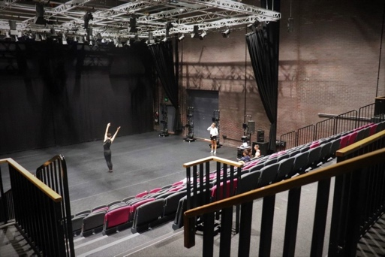

**Thank you**