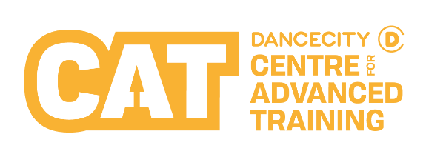
Please provide an image for us to clearly see the applicant. This helps us to remember you after the audition.

This can be attached to your form or emailed to the contact details overleaf.


Audition Application Form

Applicant’s Details
First Name |  | Last Name
Date of Birth |  | Preferred Pronouns (please tick) |  | ☐ She/Her ☐ He/Him ☐ They/Them  ☐ Other: ___________ ☐ Prefer not to say
Address
Postcode |  | Current Academic School
Ethnic Group  (Optional -  please tick) | ☐ White  ☐ Gypsy or Traveller  ☐ Black or Black British -Caribbean  ☐ Black or Black British - African  ☐ Other Black Background | ☐ Asian or Asian British - Indian  ☐ Asian or Asian British -Pakistani  ☐ Asian or Asian British - Bangladeshi  ☐ Chinese  ☐ Other Asian Background |  |  |  | ☐ Mixed - White & Black Caribbean  ☐ Mixed - White & Black African  ☐ Mixed -White & Asian  ☐ Other Mixed Background  ☐ Arab  ☐ Other Ethnic Background  ☐ I do not wish to give this info
Please share whether you have any disabilities, access requirements or medical conditions (Optional)

Parent / Guardian’s Details

First Name |  | Last Name
Email |  | Relationship to Applicant
Mobile Number |  | Home Tel Number

Your Application

Please let us know which programme you are applying for (please tick) | ☐ Dance City CAT Contemporary Programme  ☐ Dance City CAT Street Dance Programme
Please let us know which First Stage Audition session(s) you would be available to attend.
Please see overleaf for dates and times. We will make every effort to accommodate your first choice however, we are unable to guarantee availability.
Please let us know why you want to join the Dance City CAT.
What are your long-term goals?
Have you had any previous dance experience? If yes, please tell us more.
Parents or Guardians (This question is optional) - Department for Education grants are available to cover all, or part, of CAT tuition fees where relevant annual household income is less then £70,000 approx. Please indicate below whether you would be eligible to apply for a grant.

☐ Yes ☐ No
Please turn over for additional information

Additional Information

Taster Workshops
Attending a free Taster Workshop or Boys’ Workshop will help those interested in applying for an audition to find out more about what it is like to be a CAT Student before auditioning. These sessions are an opportunity to take part in a class and watch current CAT students in rehearsals. Students and parents are also invited to a short presentation about the CAT, which will conclude with a question-and-answer session.
Taster Workshops or Boys’ Workshops can be booked online or by contacting the details below.

CAT Contemporary Dance City Newcastle |  | CAT Street Dance The Fire Station, Sunderland
Taster Workshops  - Wednesday 22 February 2023  10:30am – 1:15pm or 1:30pm – 4:15pm  - Wednesday 12 April 2023  10:30am – 1:15pm or 1:30pm – 4:15pm |  | Taster Workshops  - Sunday 12 February 2023  11am – 1pm  - Sunday 19 March 2023  11am – 1pm  - Sunday 14 May 2023  11am – 1pm
Boys Workshop
- Thursday 13 April 2023
10am – 2pm

Auditions
Open auditions are held in the summer each year for entry in September to both of our CAT programmes.
Applicants must complete and return this audition application form to the address at the bottom of this page to reserve a place on their preferred audition date.
CAT Contemporary Dance City Newcastle |  | CAT Street Dance The Fire Station, Sunderland
First Stage Auditions |  | First Stage Auditions
- Saturday 20 May 2023  1pm – 3pm or 3:30pm – 5:30pm  - Sunday 21 May 2023  10:30am – 12:30pm or 1pm – 3pm |  | - Saturday 28 May 2022  1pm – 3pm
Second Stage Auditions (invite only) |  | Second Stage Auditions (invite only)
- Saturday 10 June 2023  11am – 5pm (latest)  - Sunday 11 June 2023  11am – 5pm (latest) |  | - Sunday 18 June 2023  11am – 5pm (latest)
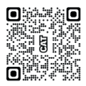
For more information about the CAT Programme, scan the QR code with your smart device’s camera.

Contact:
Post: CAT, Dance City, Temple Street, Newcastle upon Tyne, NE1 4BR

Tel: 0191 269 5578
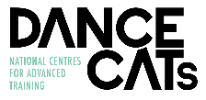
Email: CAT@dancecity.co.uk

