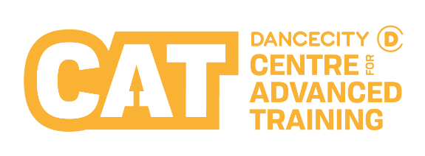
Please provide an image for us to clearly see the applicant. This helps us to remember you after the audition.

This can be attached to your form or emailed to the contact details overleaf.

Audition Application Form

Applicant’s Details
First Name |  | Last Name
Date of Birth |  | Preferred Pronouns (please tick) |  | ☐ She/Her ☐ He/Him ☐ They/Them  ☐ Other: ___________ ☐ Prefer not to say
Age on 01/09/24
Address
Postcode |  | Current Academic School
Ethnic Group  (Optional -  please tick) | ☐ White  ☐ Gypsy or Traveller  ☐ Black or Black British -Caribbean  ☐ Black or Black British - African  ☐ Other Black Background | ☐ Asian or Asian British - Indian  ☐ Asian or Asian British -Pakistani  ☐ Asian or Asian British - Bangladeshi  ☐ Chinese  ☐ Other Asian Background |  |  |  | ☐ Mixed - White & Black Caribbean  ☐ Mixed - White & Black African  ☐ Mixed -White & Asian  ☐ Other Mixed Background  ☐ Arab  ☐ Other Ethnic Background  ☐ I do not wish to give this info
Please share whether you have any disabilities, access requirements or medical conditions (Optional)

Parent / Guardian’s Details

First Name |  | Last Name
Email |  | Relationship to Applicant
Mobile Number |  | Home Tel Number
Your Application

Please let us know which programme you are applying for (please tick) | ☐ Dance City CAT Contemporary Programme  ☐ Dance City CAT Street Dance Programme
Please let us know which Open Audition session(s) you would be available to attend.
Please see overleaf for dates and times. We will make every effort to accommodate your first choice however, we are unable to guarantee availability.
Please let us know why you want to join the Dance City CAT.
What are your long-term goals?
Have you had any previous dance experience? If yes, please tell us more.
How did you first hear about the Dance City CAT? (please circle)
Word of Mouth Spotted Workshop Dance Teacher Online Social Media Other: ______________

Parents or Guardians (This question is optional) - Department for Education grants are available to cover all, or part, of CAT tuition fees where relevant annual household income is less then £70,000 approx. Please indicate below whether you would be eligible to apply for a grant.

☐ Yes ☐ No
Additional Information

Taster Workshops
Attending a free Taster Workshop or Boys’ Workshop will help those interested in applying for an audition to find out more about what it is like to be a CAT Student before auditioning. These sessions are an opportunity to take part in a class. Students and parents are also invited to a short presentation about the CAT, which will conclude with a question-and-answer session.
Taster Workshops or Boys’ Workshops can be booked online or by contacting the details below.

CAT Contemporary Dance City Newcastle |  | CAT Street Dance The Fire Station, Sunderland
Taster Workshops  - Saturday 9 March 2024  - Saturday 16 March 2024  - Saturday 20 April 2024  - Saturday 4 May 2024 |  | Taster Workshops  - Saturday 16 March 2024  - Saturday 4 May 2024
Boys Workshop
- Sunday 28 April 2024

Auditions
Open auditions for entry in September are held each year for both of our CAT programmes.
Applicants must complete and return this audition application form to the contact details at the bottom of this page to reserve a place on their preferred audition date.
CAT Contemporary Dance City Newcastle |  | CAT Street Dance The Fire Station, Sunderland
Open Auditions |  | Open Auditions
- Sunday 19 May 2024  - Saturday 8 June 2024  - Sunday 9 June 2024 |  | - Sunday 26 May 2024  - Sunday 16 June 2024
For more information about the CAT Programme, scan the QR code with your smart device’s camera.

Contact:
Post: CAT, Dance City, Temple Street, Newcastle upon Tyne, NE1 4BR
Tel: 0191 269 5578
Email: CAT@dancecity.co.uk

